SAP Project

Enterprise structure
Define company
Edit, copy, delete,check, company code
Defin copy, delete, check plant
Assignment
Assign company code to company
other assignments
Field status variant
Define field status varinat
Assign company code to field status variants
fiscal year and posting periods
Maintain fiscal year variant
Assign company code to a fiscal year varaint
posting periods
Define variants for open posting periods
Assign company code to a fiscal year variant
Define variants for open posting periods
Gl Accounts
Gl master creation
Voucher entry posting
Display accounting entry list
Display gl balance
Display gl dr/cr balance
Enjoy accounting document entry
Park document
Post park document / display park document
Display gl master list
Display Edit chart of account
Assign company code to chart of accounts
Define account group
Define retained earnings accounts
Define tolerance group
Account payable
Define account group
Define number range ( vendor group no range )
Assign number range to vendor account group
Define vendor / customer tolerance limit
Define gl account – ap recon account
master data
Account payable transaction posting
Vendor down payment / advance payment/ special gl
Payment terms master
House bank master
Account recivable : customer accounting
Define customer group
Define no range for customer group
Assign no range to customer account group
Create gl – Ar- Recon ( account receivable ac)
Create customer master
Customer accounting transaction
Adv / dwon payment received from customer
Customer dunning process
new procedure
dunning levels
charges
minimum texts.
Asssign dunning producer to customer
Tax on sales and purchases
Taxable transaction posting
Define procedure
Define condition types
Assign country to calculation procedure
Check and change setting for tax processing
Assign condition type and key to tax proessing
Create gl master
Define tax code
Activate gl account for tax posting ( pur & sale gl )
Activate gl account for tax posting ( pur & sales gl)
Asset Accounting
Organization structure
Copy referance chart of deprecation / deprecation areas.
Assign chart of depreciation to company code.
Specify account determinatin for asset class.
Create screen layout rules for asset class.
Define number range interval.
Master creation
Transactional data
Tds
Check withholding tax countries
Define withholding tax keys
Withholding tax type
Define withholding tax type for payment posting
Define withholding tax codes.
Check recipient types
Assign withholding tax type to company code
Activate extended withholding tax
Create gl account (tds payable)
Define accounts for witholding tax to be paid over
Master data updating

1.Define
Define company
Path = spro / enterprise structure / definition / financial accounting / define company
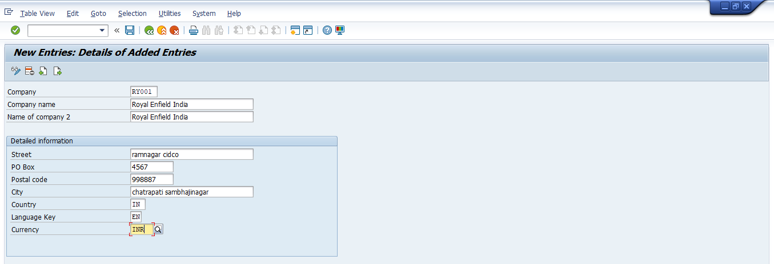
2. edit , copy, delete, check company code
Path= spro/sap ref img/enterprise structure/defination/ finacial accounting/define company
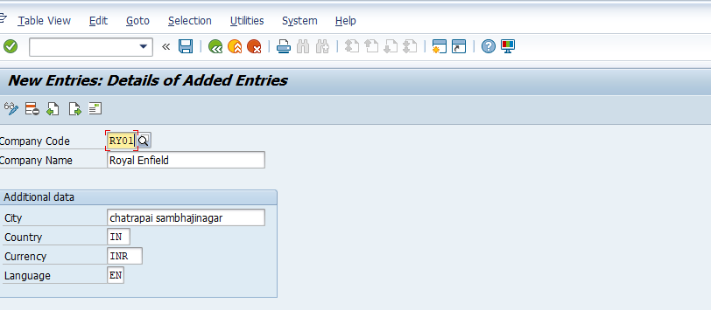
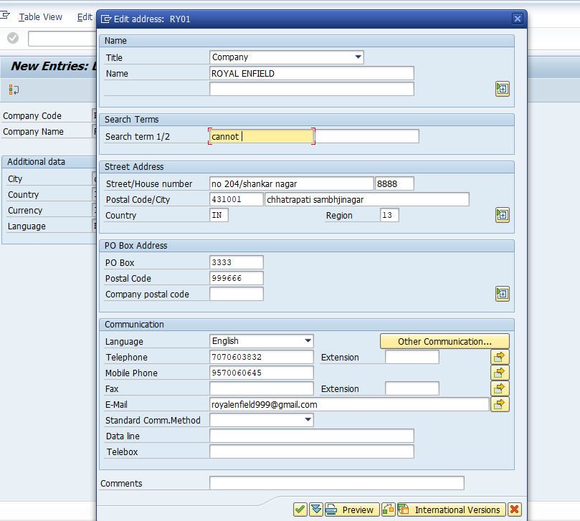
3. assignment
assign company code to company code
path = spro/sap Ref img / enterprises structure/assignment/financial accounting/assign company code to company
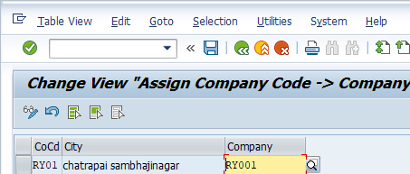
4. Field status variant
Path = spro/sap ref img/financial accunting (new)/financial accounting global settings(new)/ledgers/field/define field status variants
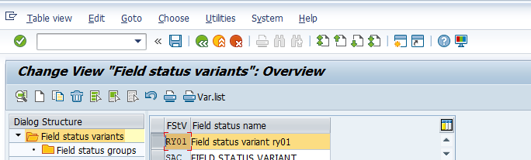
Fiscal year posting periods
Assign the fiscal year variant
Path = spro/sap ref img/fincacial accounting new/financial accounting global setting (new)/ledgers/fiscal year and posting periods/ assign company code to fiscal yeat variant.
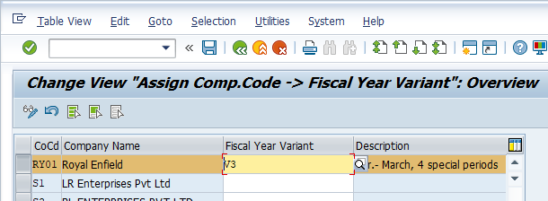
Field status variant
Path = spro/sap ref img/fincial accounting new/fincial accounting global setting new/ ledger/field, assign company 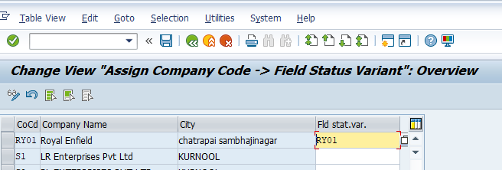
Fiscal year posting periods
Maintain fiscale year variant
Path = spro/sap ref img/fincial accounting new/fincial accounting global setting new/ ledger/ fiscal year and posting period
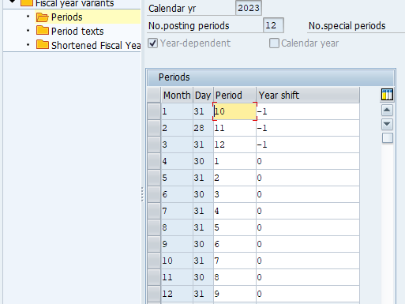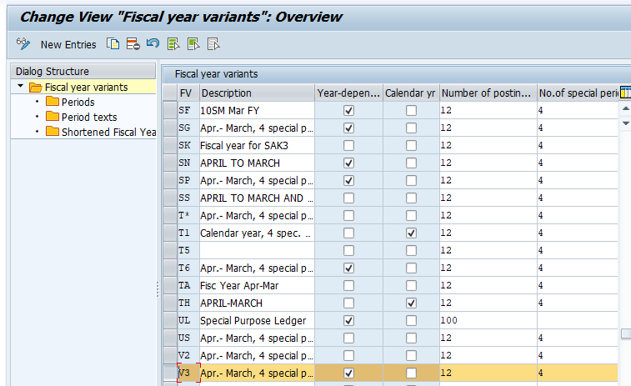
Posting Periods Define Variants for Open Posting Periods
Path = SPRO /SAP IMG Menu /Financial Accounting → Financial Accounting Global Settings → Ledgers → Fiscal Year and Posting Periods → Posting Periods → Define Variants for Open Posting Periods Tcode OBBO 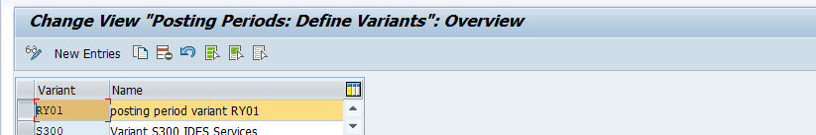
Define Variants for Open Posting Periods
SPRO/SAP IMG Menu Financial Accounting → Financial Accounting Global Settings → Ledgers → Fiscal Year and Posting Periods → Posting Periods → Open and Close Posting Periods Tcode =OB52 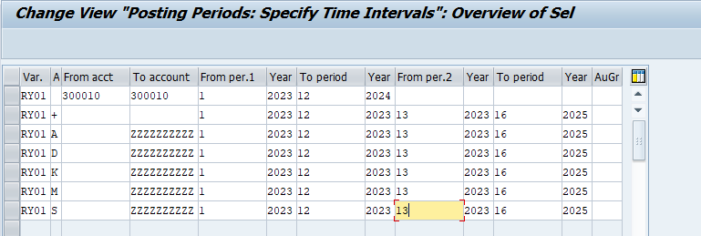
- + = Valid for all account type
- A = Asset
- D = Customers
- K = Vendors
- M = Materials
- S = General Ledger Account
GL Accounts
Edit Chart of Accounts SPRO/SAP IMG Menu/Financial Accounting → General Ledger Accounting → Master Data → G/L Accounts → Preparations → Edit Chart of Accounts List 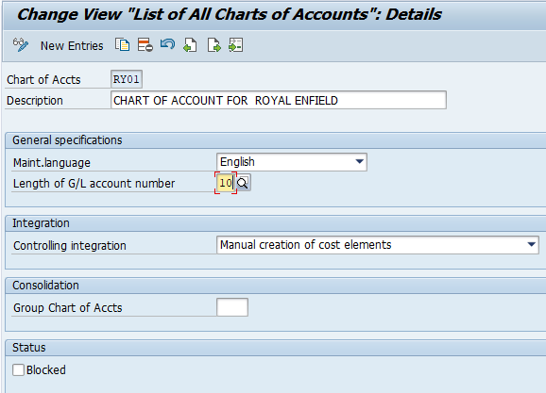
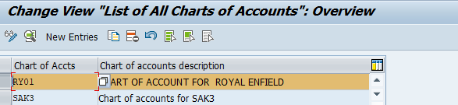
Assign Company Code to Chart of Accounts
Path = spro/sap RMG Men/Financial Accounting → General Ledger Accounting → Master Data → G/L Accounts → Preparations → Assign Company Code to Chart of Accounts Tcode OB62 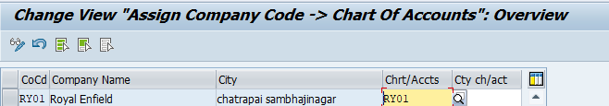 Define Account Group
Spro /sap IMG Menu/Financial Accounting → General Ledger Accounting → Master Data → G/L Accounts → Preparations → Define Account Group Tcode OBD4 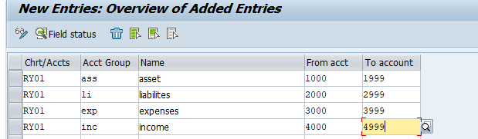
Define Retained Earnings Account
Spro/ sap ref IMG Menu/ Financial Accounting → General Ledger Accounting → Master Data → G/L Accounts → Preparations → Define Retained Earnings Account Tcode OB53 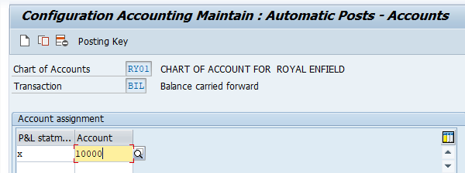

Define tolerance group
Define tolerance group = spro/sap ref img/ financial accounting new/ general ledger accounting new/ business transaction/open item clearing/open item process/clearing difference/define tolerance group g/l accounting.
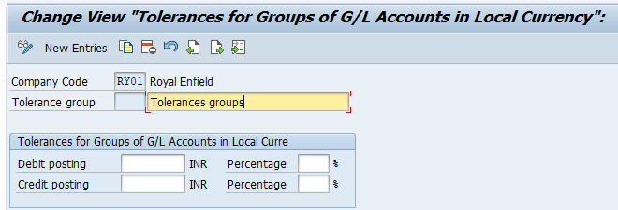
Define tolerance group for employees
Path : spro/sap ref img/ financial accounting new/ general ledger accounting new/ business transaction/open item clearing/open item process/clearing difference/define tolerance group for employees
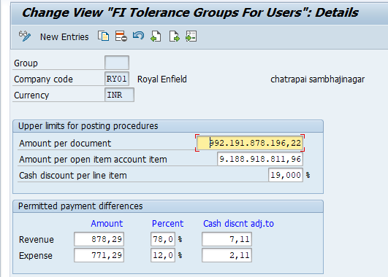
Gl Accounting
- Gl master creation
T code = FSOO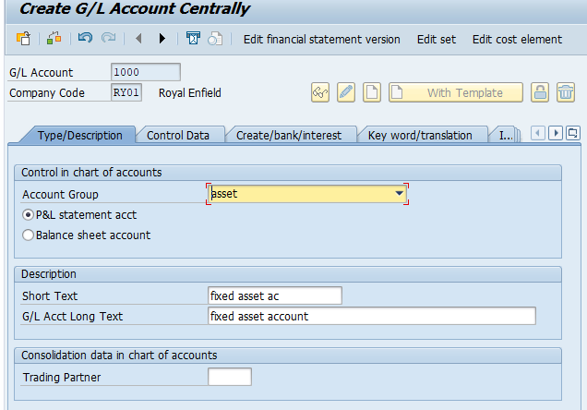
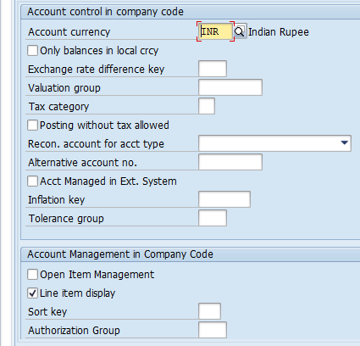
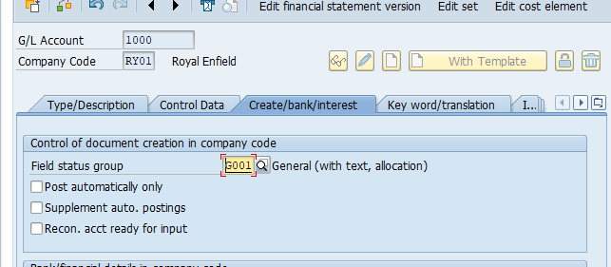

Vocuher entry posting = T- code = f-02
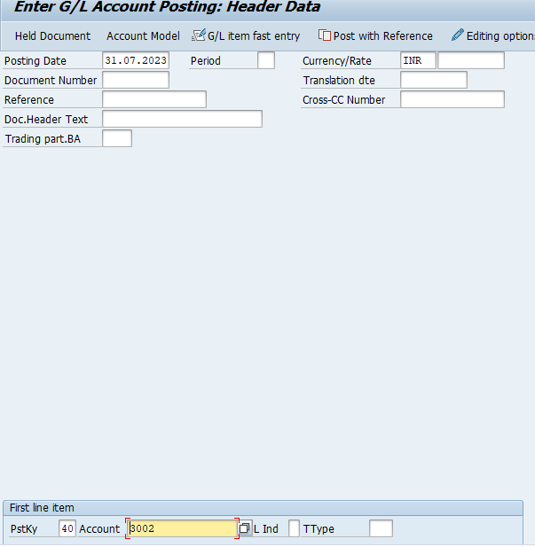

40 = Dedite Entry
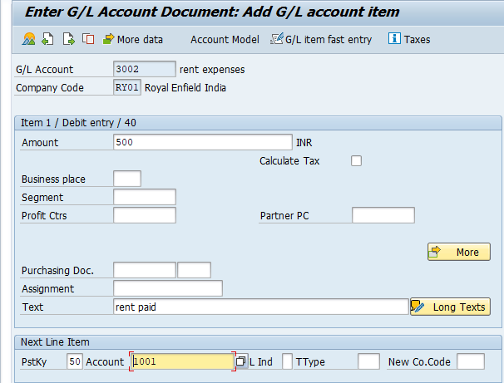

50 = Credit Entry
Sap enjoy transaction T- code = FB50
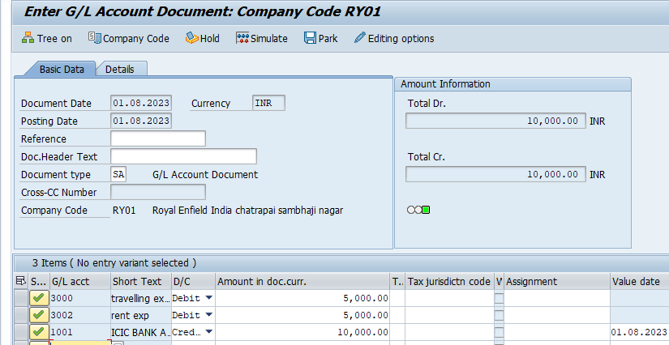
Display accounting entry T-code = FB03
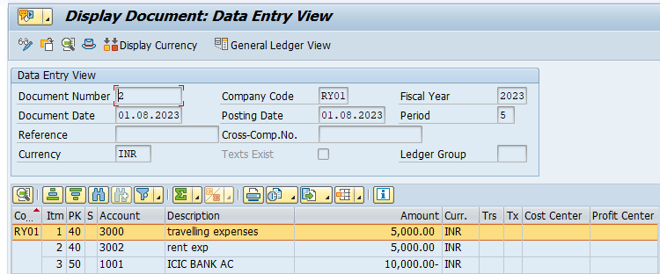
Display General ledger account balance T-code = FS10N
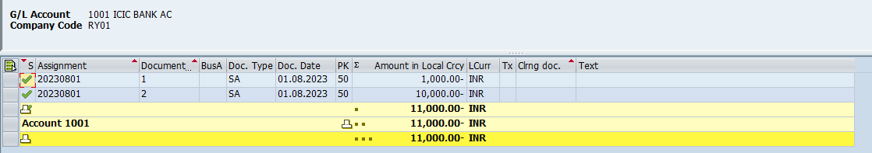
Park entry = T – code =f-02/fb50/fv50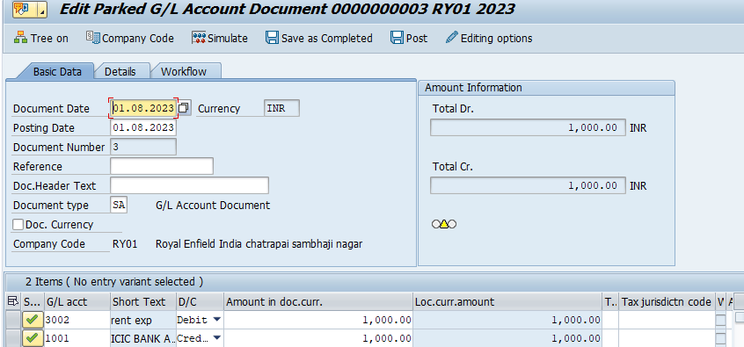
Post park entry/display park entry T-code = FBV0
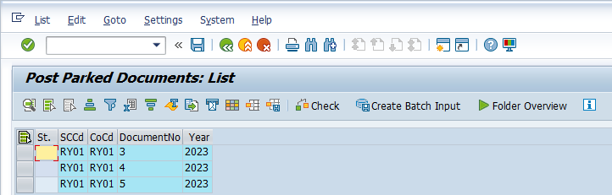
Display trail balance = T-Code = F.08
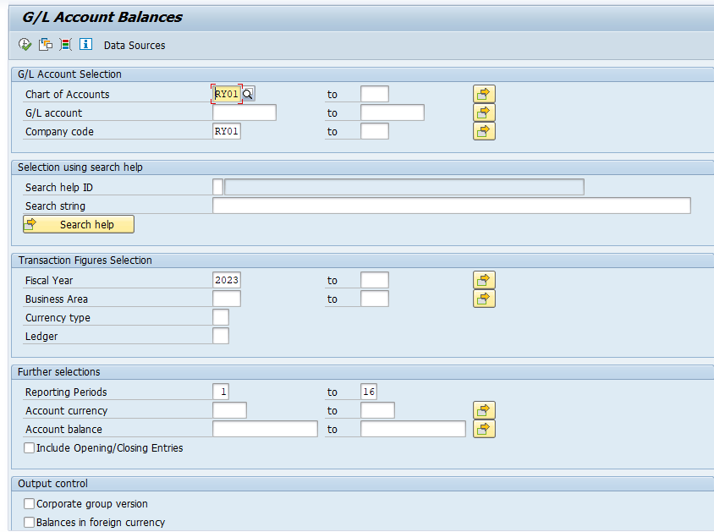
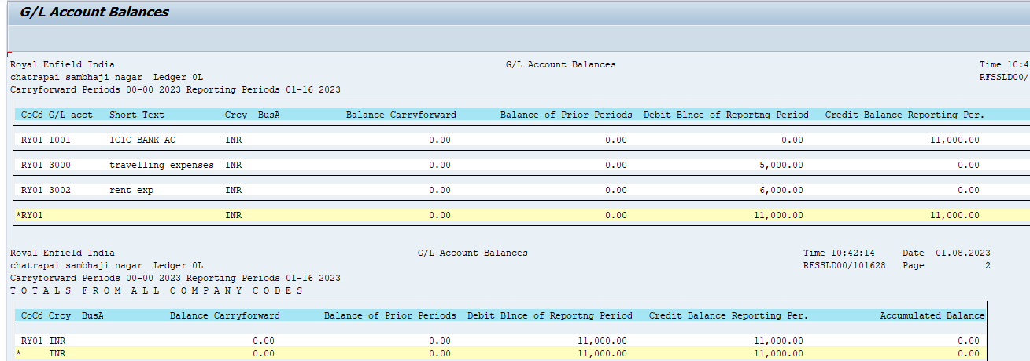

Account payable
Account group
- Supplier vendor = vendor provide material to company day day basic.
- Service vendor = all type service provider
Configuration
- Define account group
Path = spro/spa ref img financial accounting (new) financial accounting gobal setting / account reciable- account payable/vendor master data/ preparation for creating vendor master data/define account group with screen layout ( vendor)
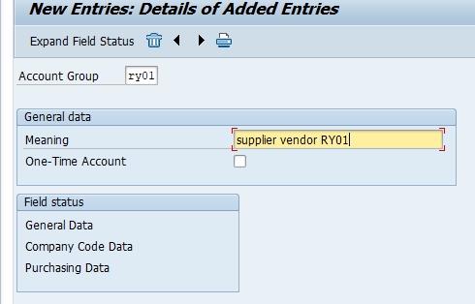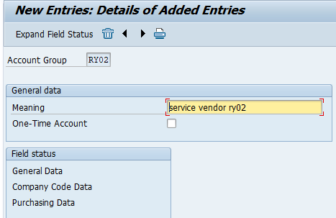

- Define number range ( vendor group no range) T – code = xkn1
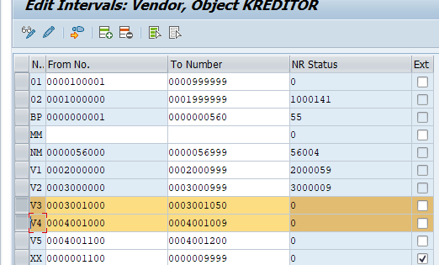

- Assign number range to vendor account group
Path = spro/spa ref img financial accounting (new) financial accounting gobal setting / account reciable- account payable/vendor master data/ preparation for creating vendor master data/ assign number range to vendor account group
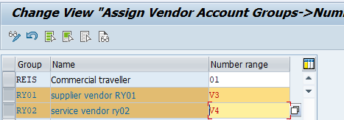
- Define vendor / customer tolerance limit
Path = spro/spa ref img / financial accounting/ account recieable/ account payable/ bussines transaction/open item clearing/ clearing differences /define tolerence for customer tolernce 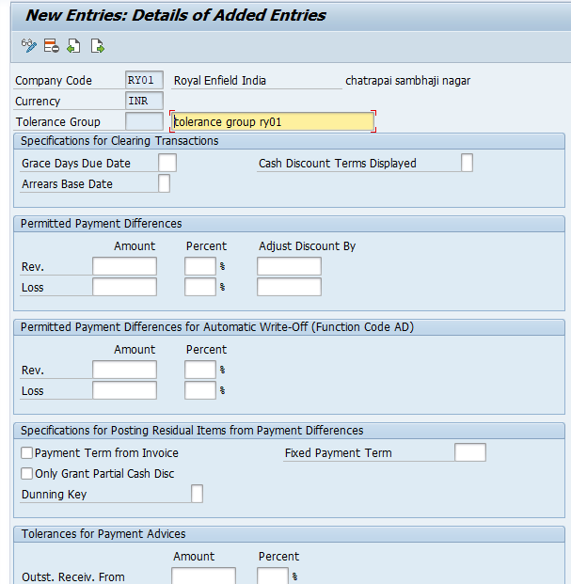

What is ap recon account?
Ap recon account is subledger account in which purpose and while creating we need to assign ap recon account
Master Data
Create G/l account ap.recon account – T- code = FS00 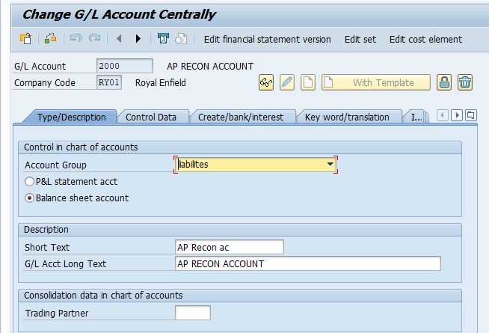
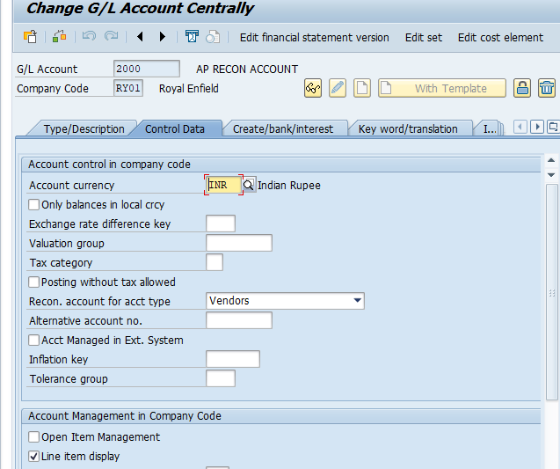
- Create vendor master t- code = FK01
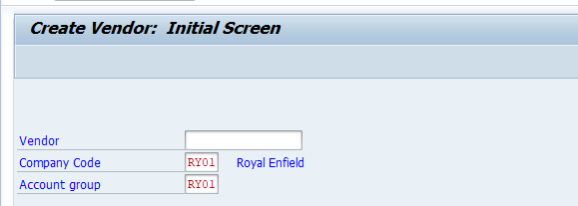
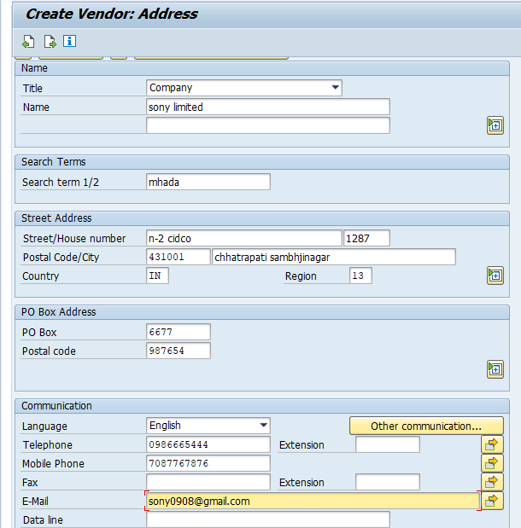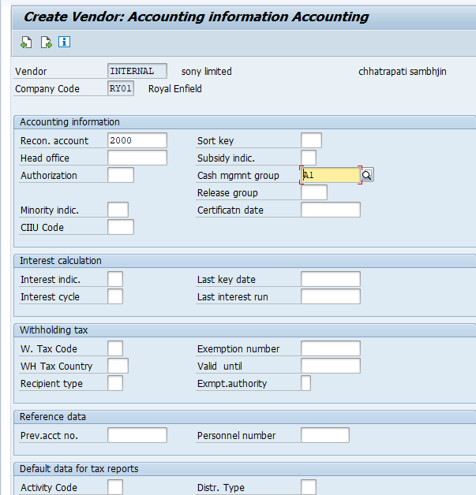
Change in vendor master : T – code : FK02 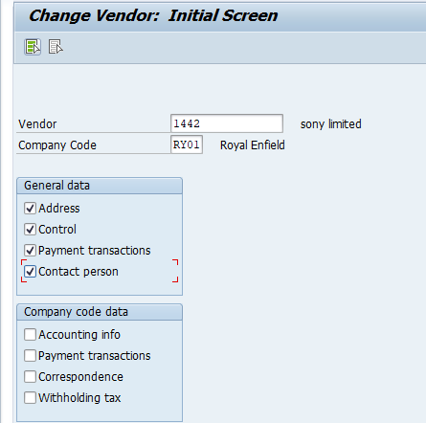rnf

Enter and edit vendor master creation
Display vendor master creation : T – code FK03
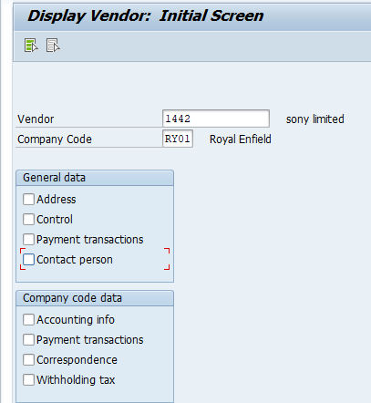
Account payable transaction posting :
Post purchases invoice : T- code = FB60 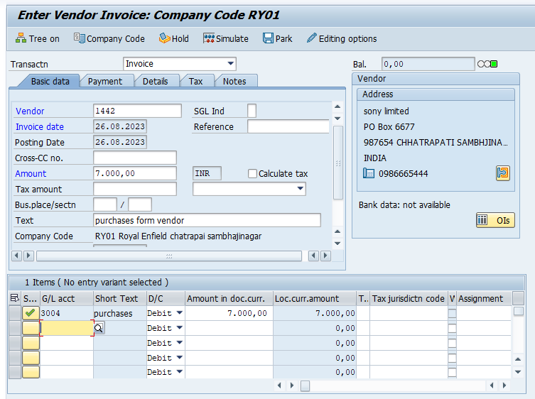
EX. Purchases ac……. d.r
To vendor ac……… c.r
Display vendor ledger : FBL1N
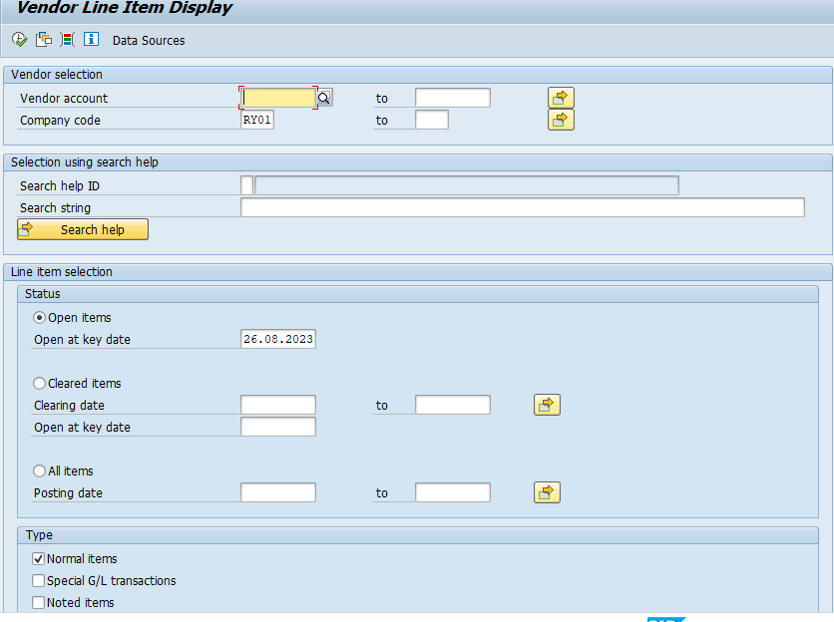
Vendor payment : F -53
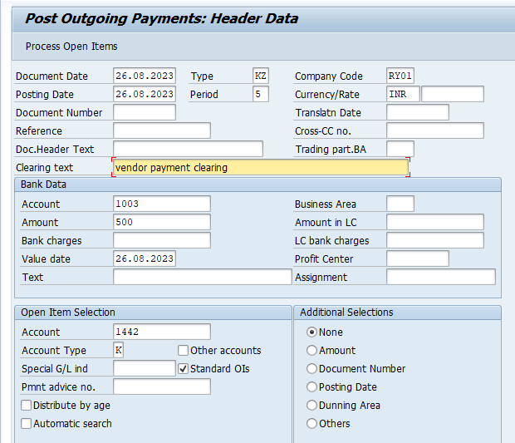
Ex. Vendor account…….. d.r
To bank account………. C.r
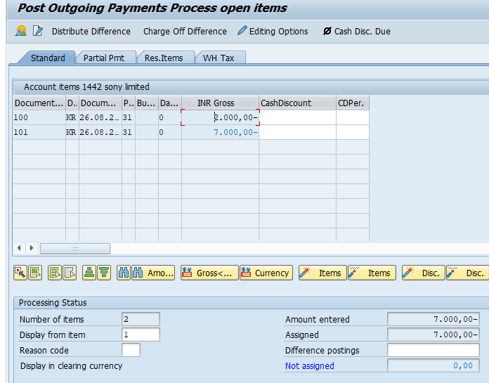
There are three types of vendor payment
- Full payment
- Partial payment
- Remainning payment – balance amt

Full payment
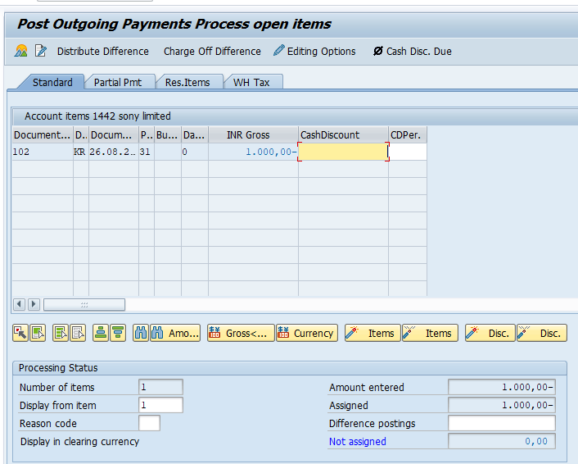

Partial payment/ half payment paid
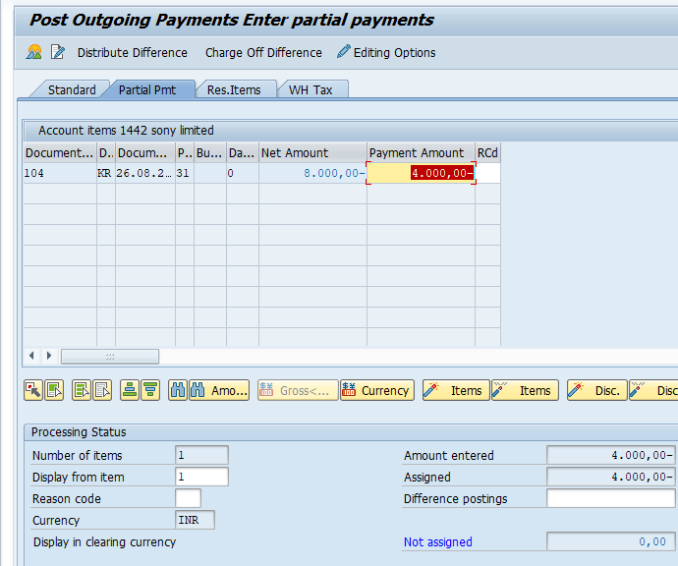
Remainning payment – balance amt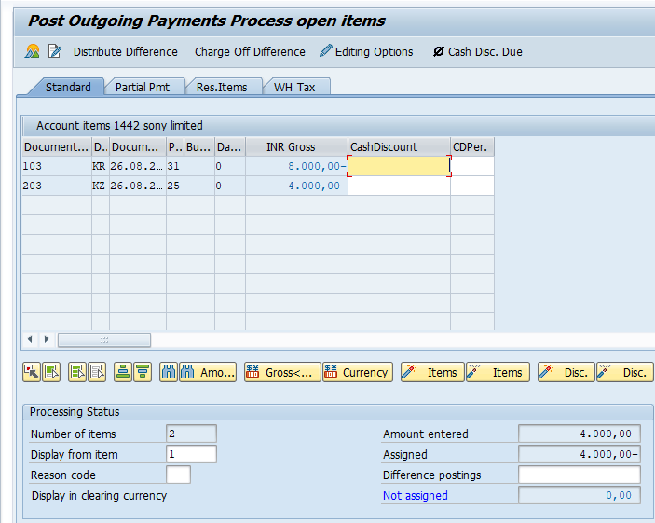
Vendor dedit note posting / purchases return : T – code : FB65
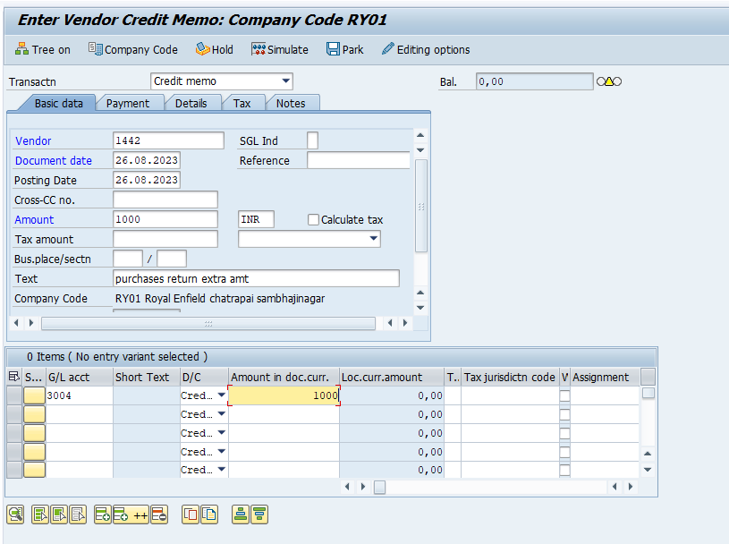
Ex . vendor account……… D.r
To purchase/service exp……… c.r
Vendor down payment / advance payment special Gl
Create special gl account ( adv paid to vendor ) T – code : FS00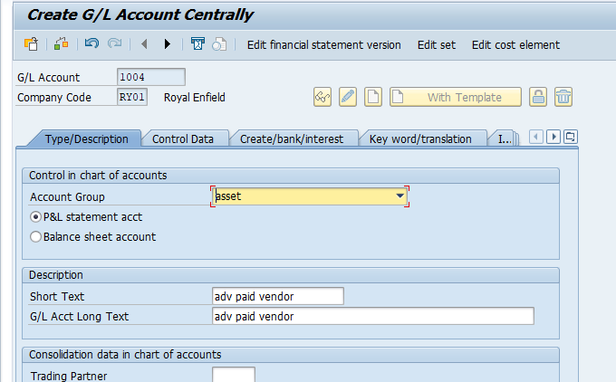
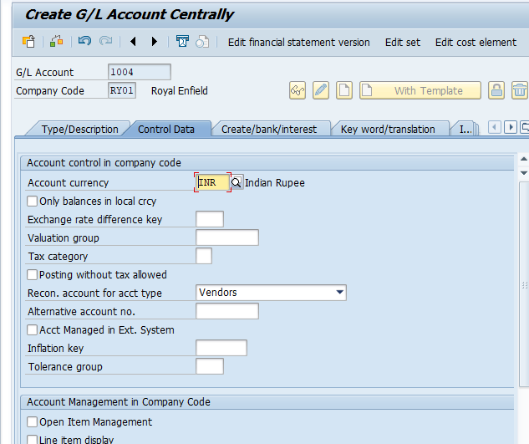
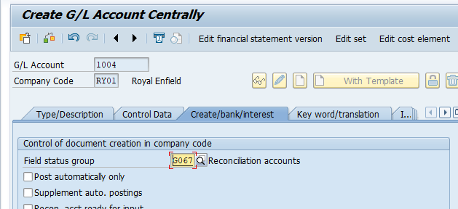
Link adv gl with normal ledger ( gl ap – recon) : T- code : OBYR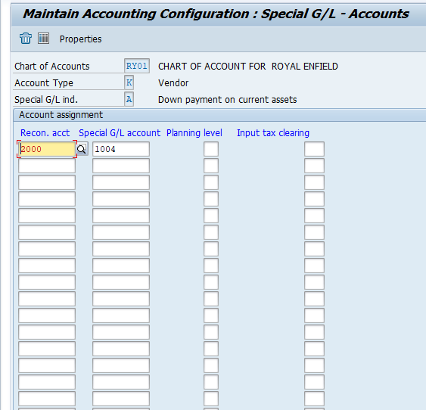
Post down payment /advance payment : T- code : F – 48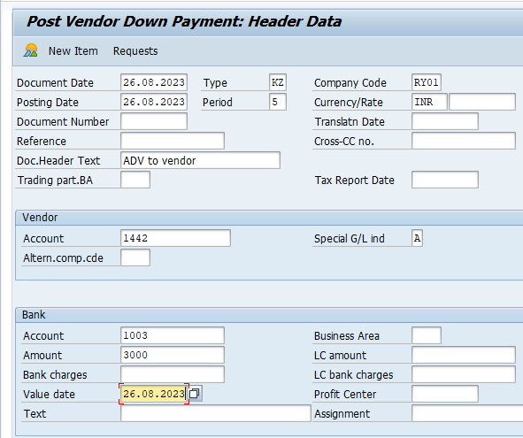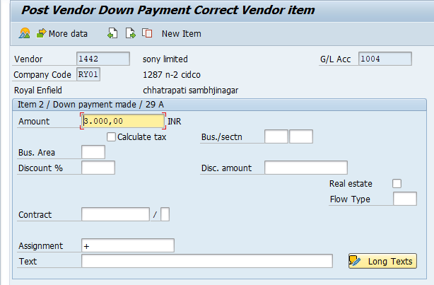
Post purchses invoice : T – code : FB60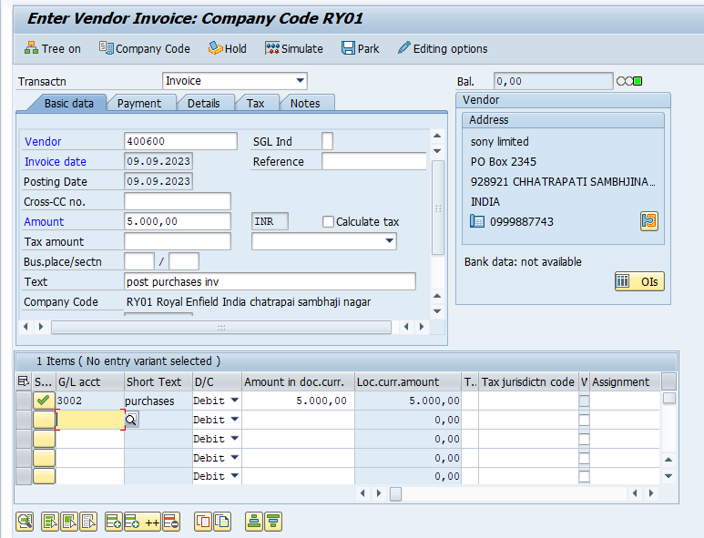
Transfer adv a/c balance to normal ledger T- code : f-54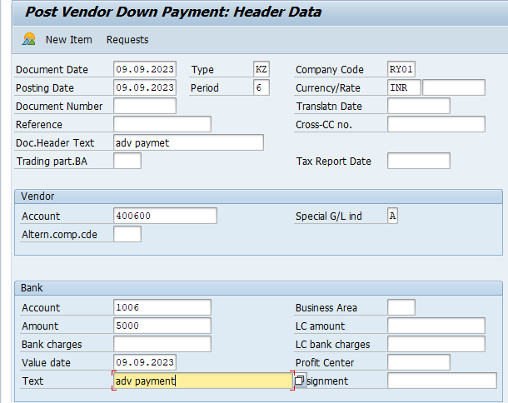

Clear vendor ac F-44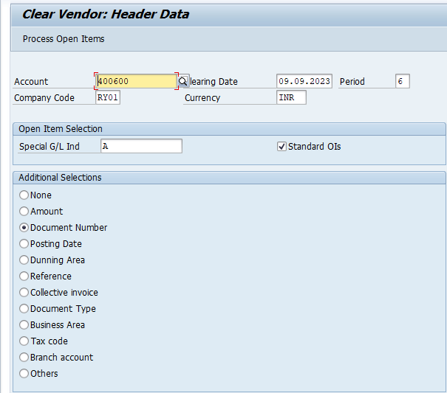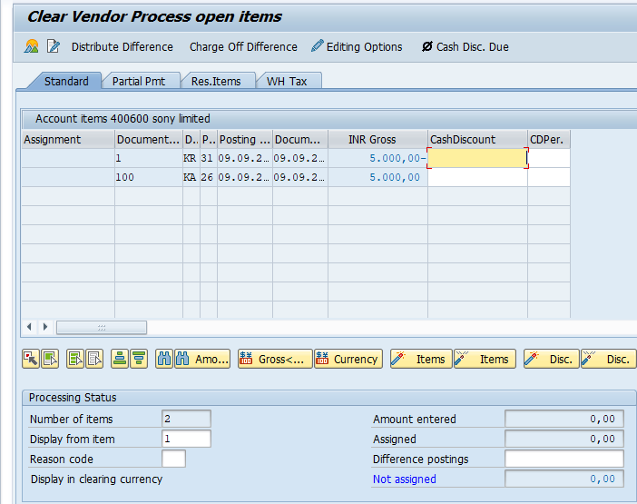
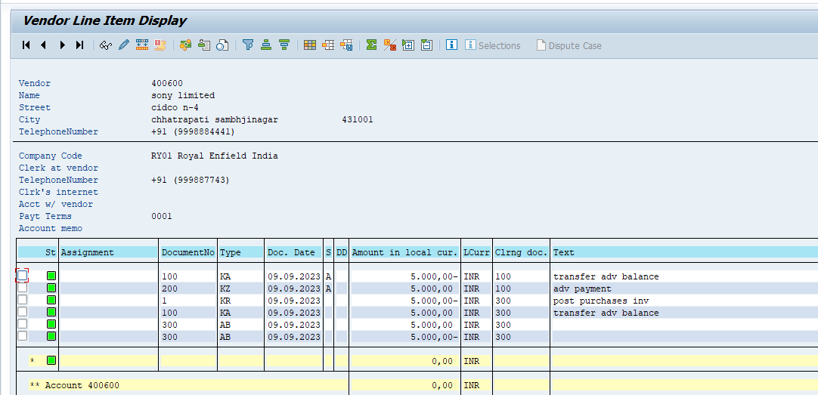

Payment terms master
Payment terms is no day to calculate invoice date for the vendor payment. Exp.30 days, 60 days, 90.120 days
T- code : OBB8
What is base line date..?
The base line date is use in SAP for payment terms calculation date below 4 type of base line dat use sap

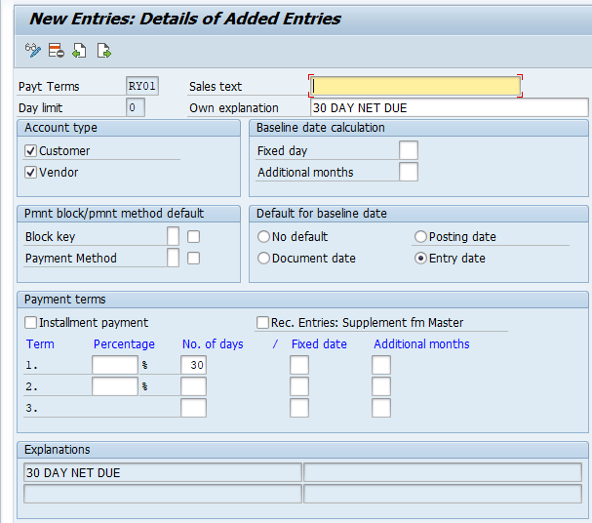
Assign new terms to vendor master T- code : FK01/FK02
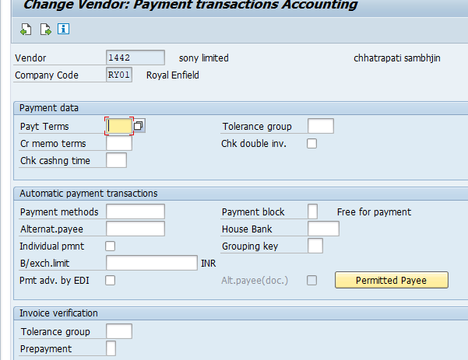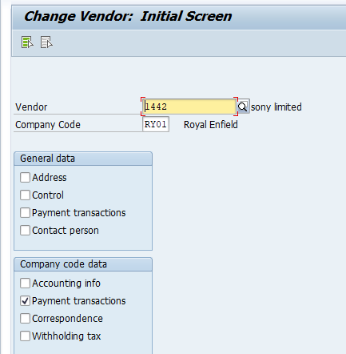
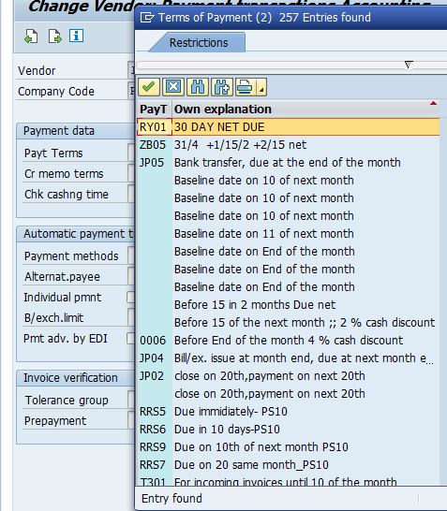

House Bank Master
What is house bank..?
House bank is won bank account company or org which use day to transaction posting
For exp. Receipt & payment account
Configuration setting
Create two gl – Ac ( receipt ac & payment Ac ) T – code = FS00
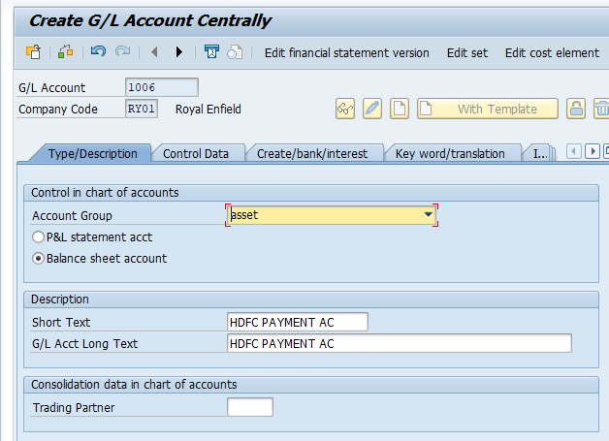

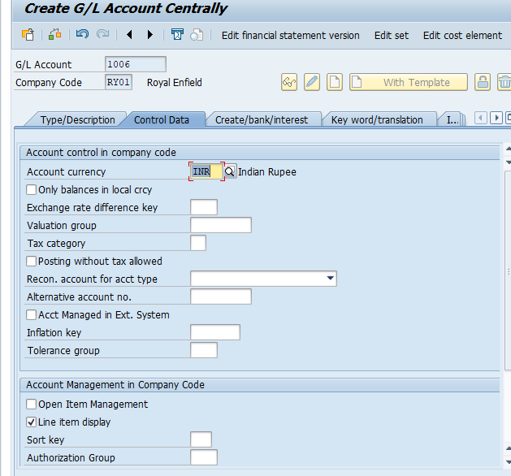

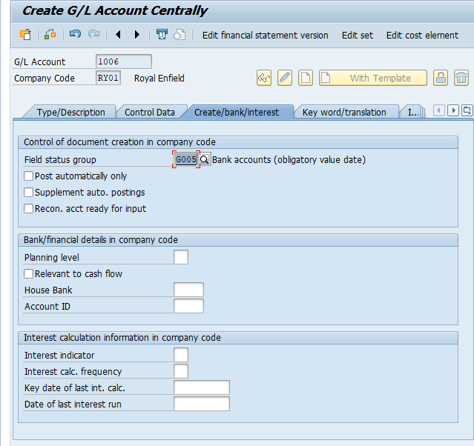

Create house bank master : FI12
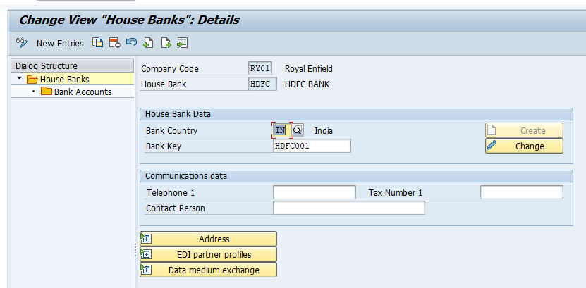
Create house bank : FI12
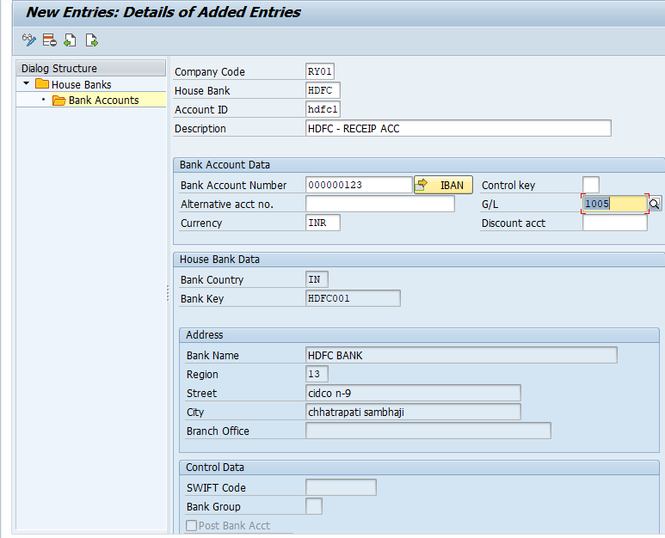
Same create payment bank account
Assign house master to receipt & payment account T- code : FS00
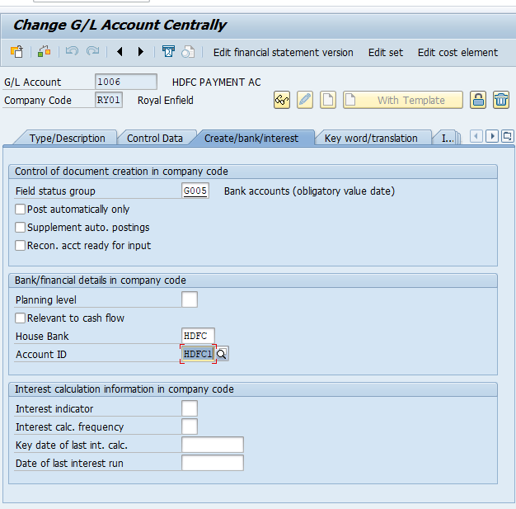
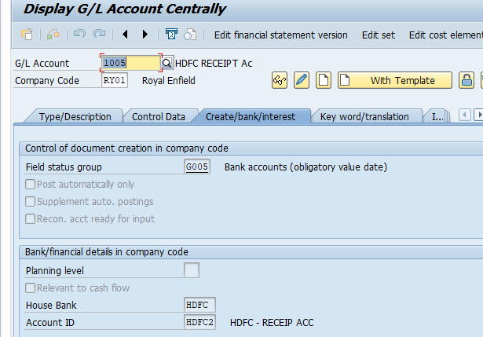

Assign house bank to vendor master T – code : FK02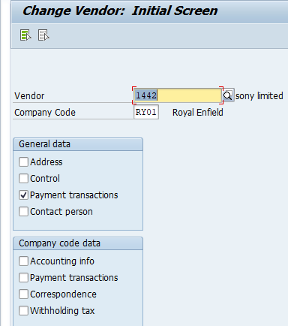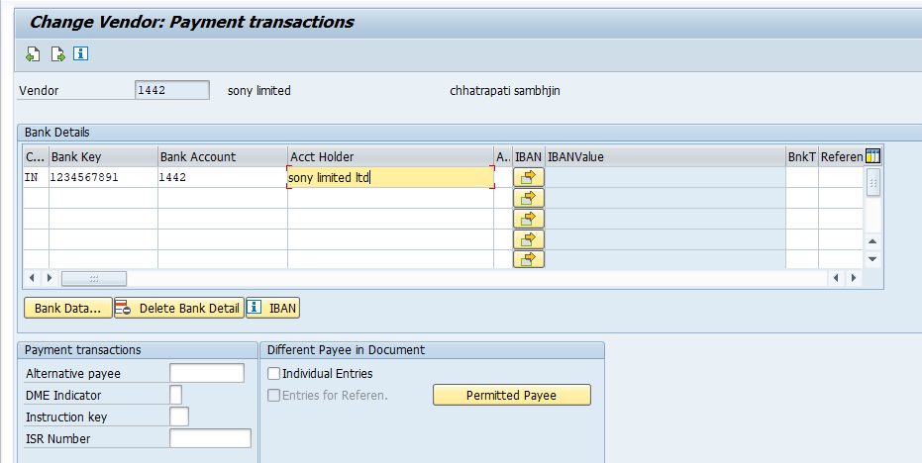

App – automatic payment program :
Configuration : T – code : FBZP
There are six steps
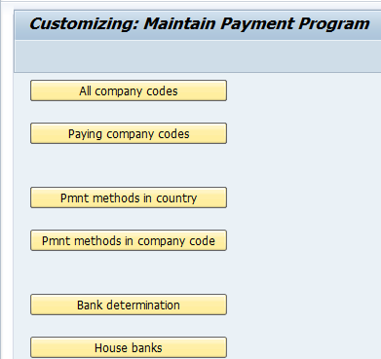

All company code
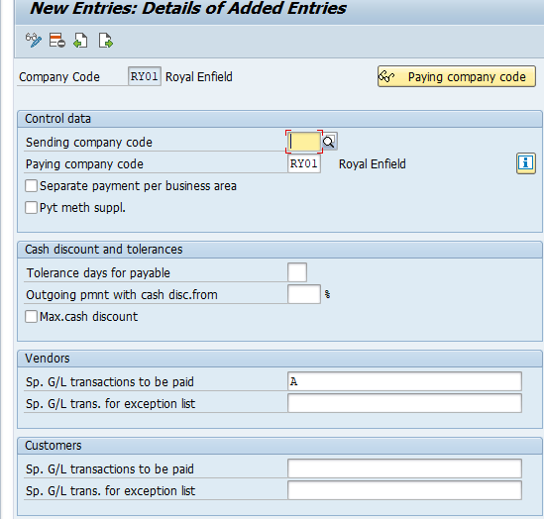
Paying company code
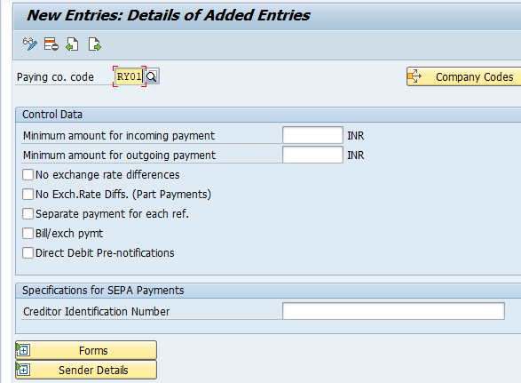
Pmnt method in country
No any activity
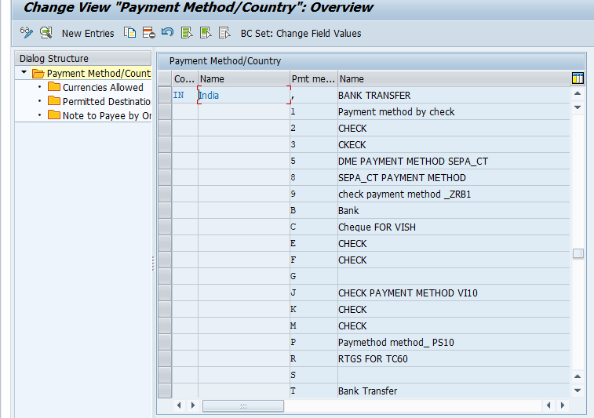

Payment method in company code
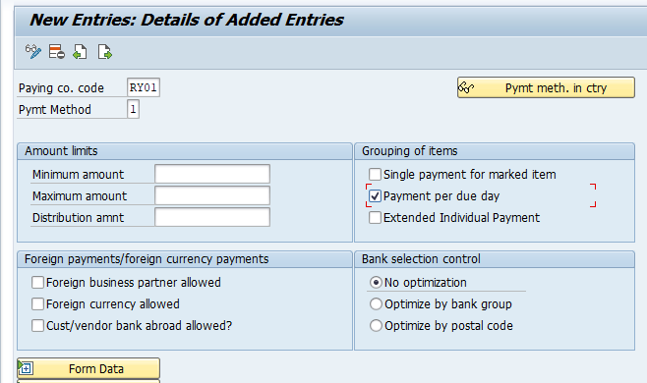
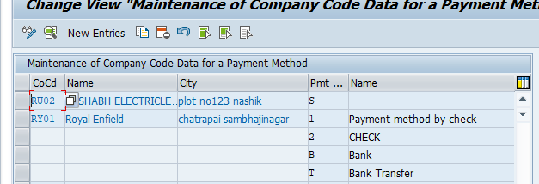
Bank determination
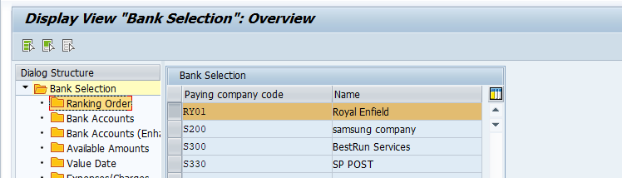
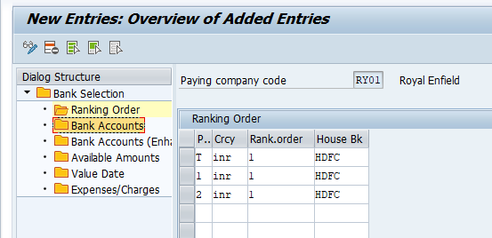
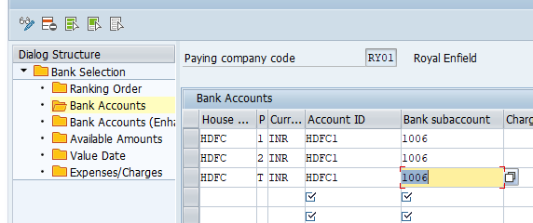
Run – APP
T – code : F110 ( multiple vendor payment. )
Purchases entry overdue very important this entry
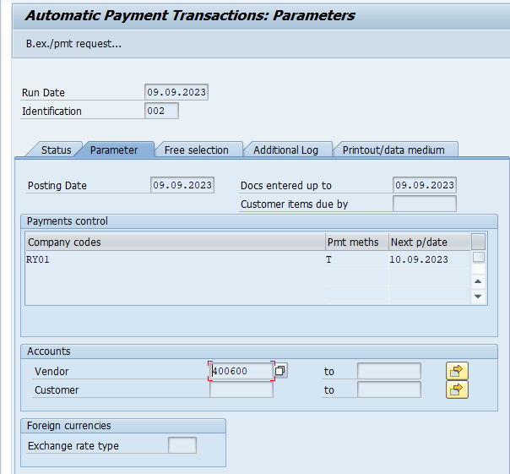
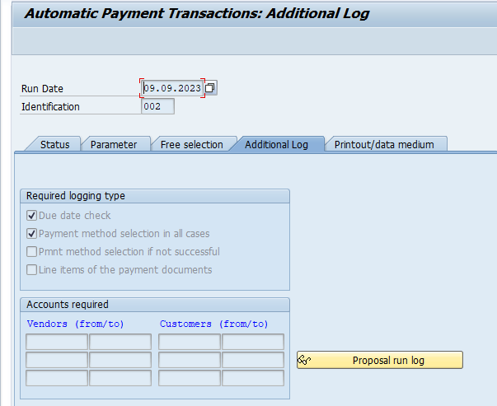

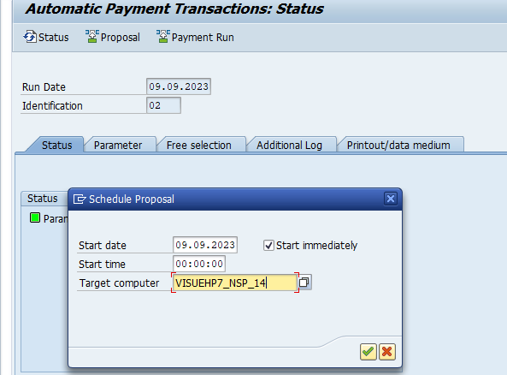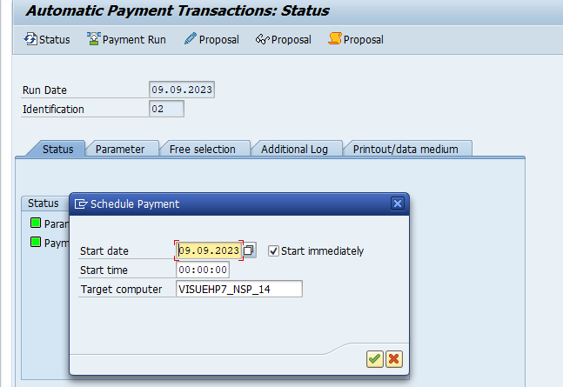

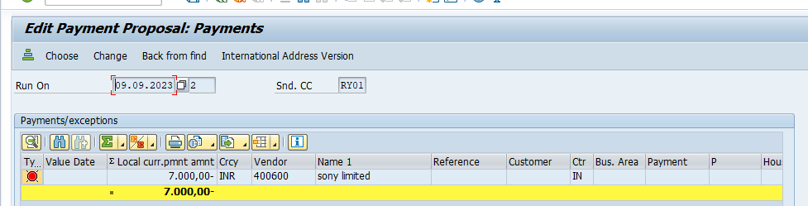

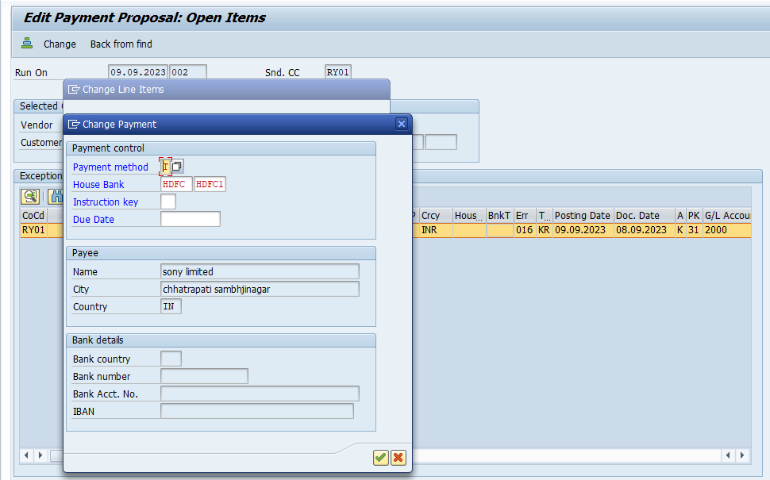
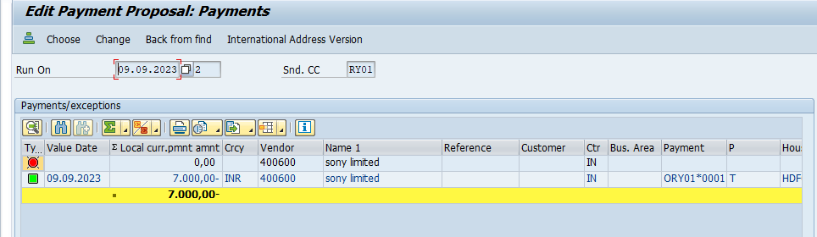
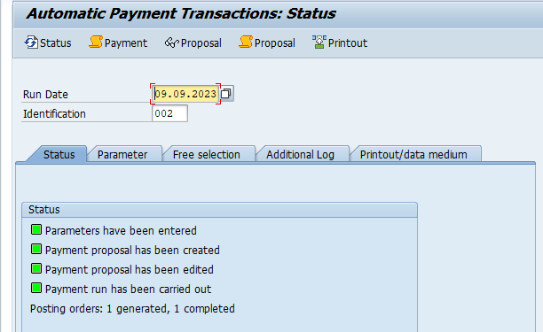
Account recivable : customer related to sale accounting
Activtity
- Sales to customer
- Customer payment receipt posting
- Customer dedit note posting
- Adv received from
- customer dunning

set configuration
- define customer group : domestic & export
- define no range for customer group
- assign no range to customer account group
- create gl - AR – RECON ( account receivable account ) T – code : FS00

- define customer group
path : spro/ sap ref img/financial accounting (new)/ account recivable & account payable/customer account / master data/ prepration for creating customer/ master data/ define account group with screen layout customer
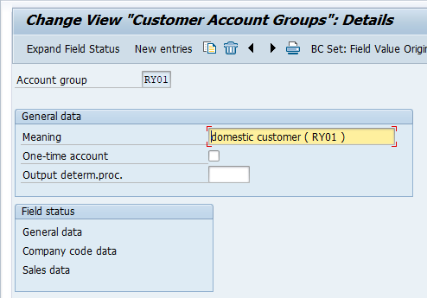
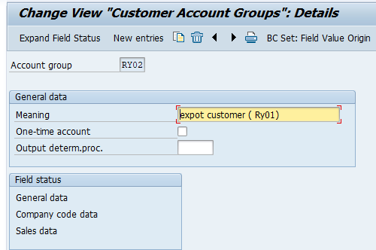

- spro/sap ref img / financial accounting (new)/ account recivable & account payable/ customer account/ master data/ prepration for creating customer/master data/ assing number range to customer acccount group 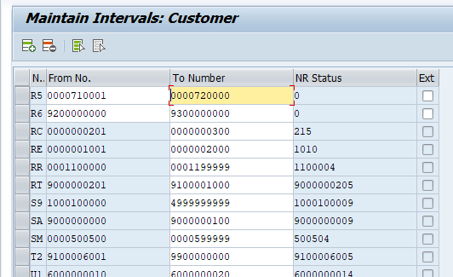

- spro/sap ref img / financial accounting (new)/ account recivable & account payable/ customer account/ master data/ prepration for creating customer/master data/ assign number range to customer account group 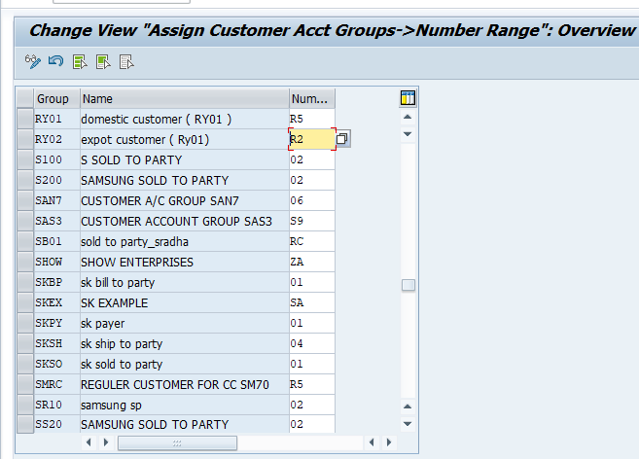
create gl AR – RECON ( Account receivable ac ) T – code : FS00
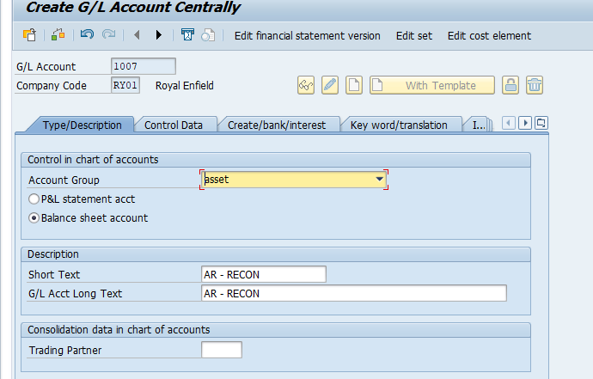
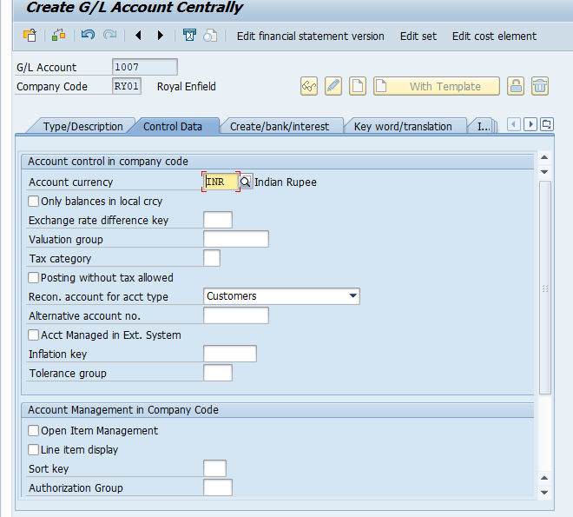
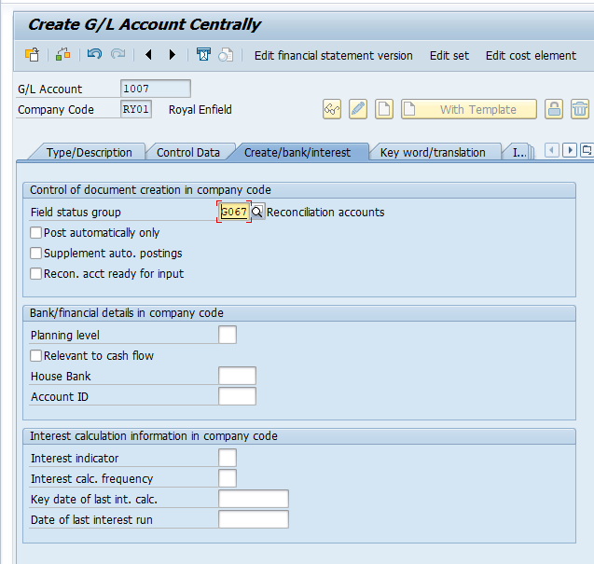

Create gl master creation

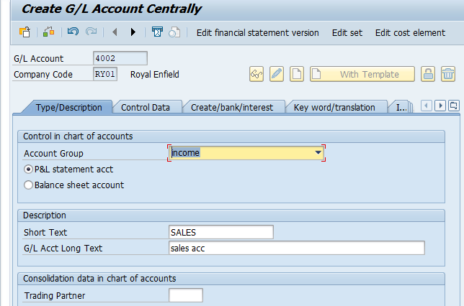

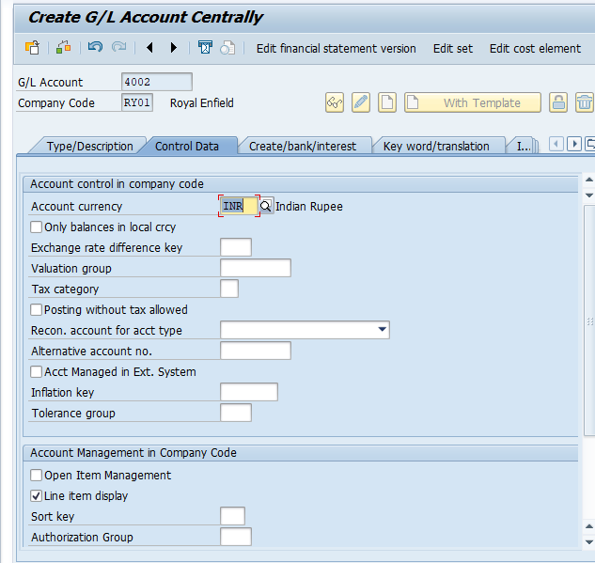
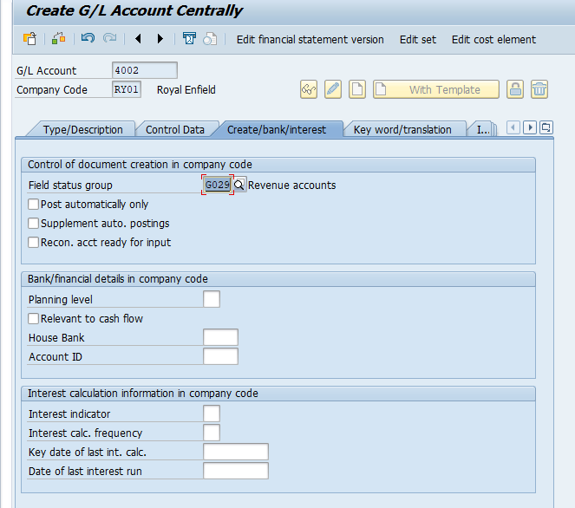
Create customer master :
- Create new customer T – code : FD01
- Change customer master t - code : FD02
- Display customer master T – code : FD03
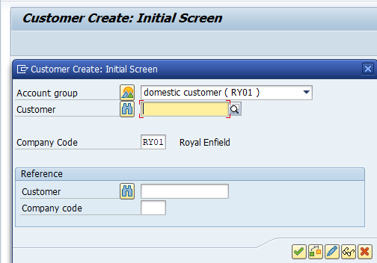
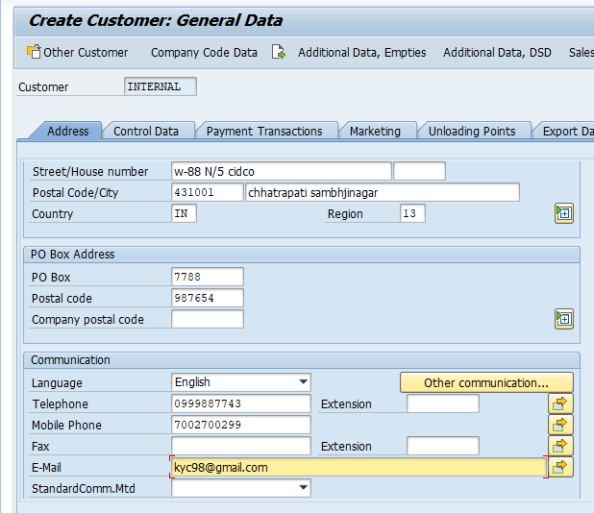
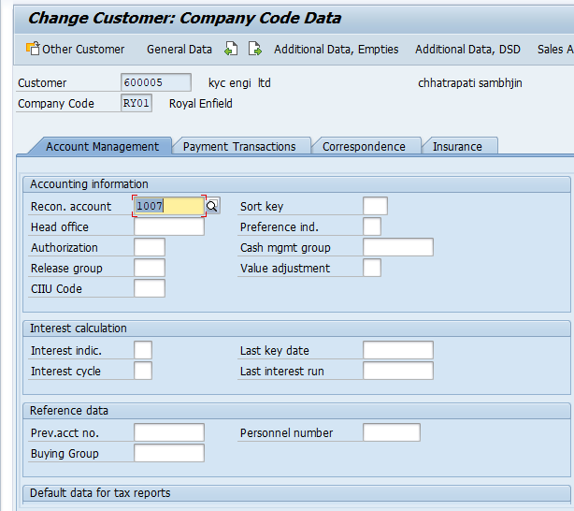

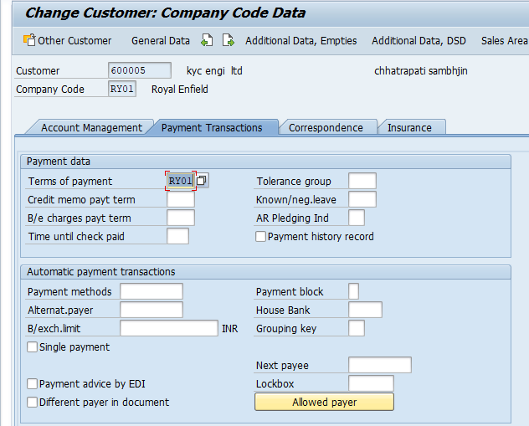

Customer accounting transaction code
Sales to customer T – code : FB70 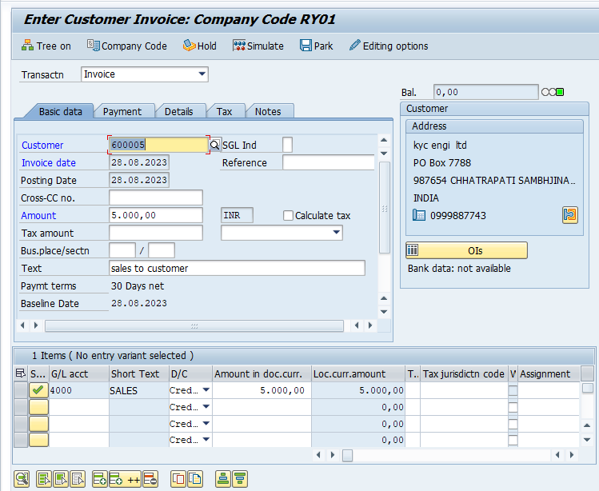
Ex. Customer ac……….d.r
To sales ac ………………c.r
Check ledger balance : FBL5N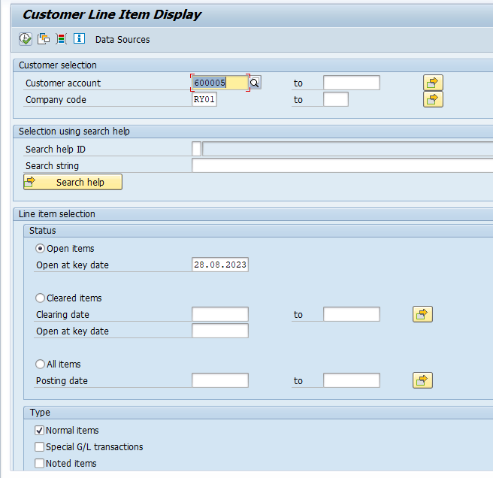
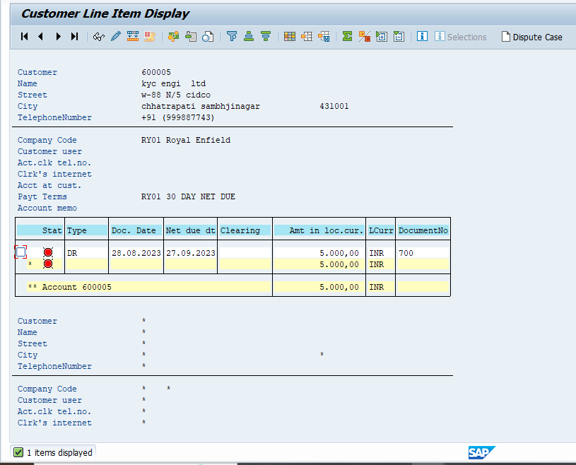
Check dr/cr balance : T – code : FD10N
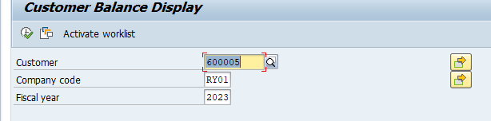
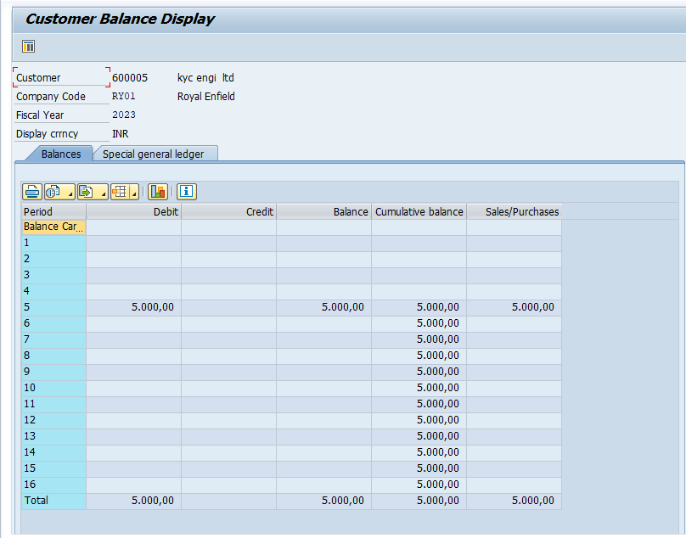
Customer payment receipt : F-28 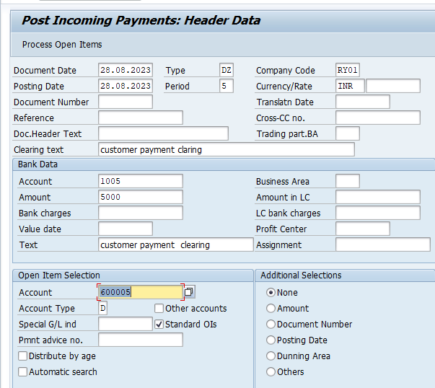
Ex. Bank account ………d.r
To customer account ……..c.r
Dedit note received from customer : T – code : FB75
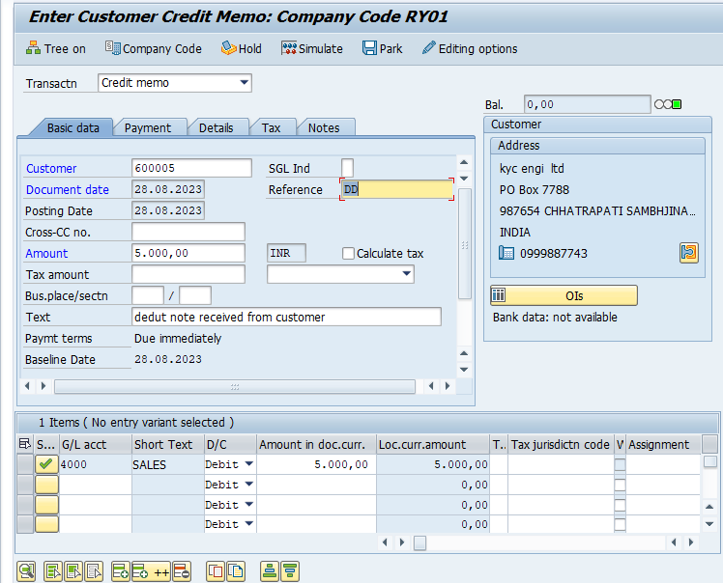
Adv / down payment received from customer
Setting :
Create one new gl account – advance received from customer T – code : FS00 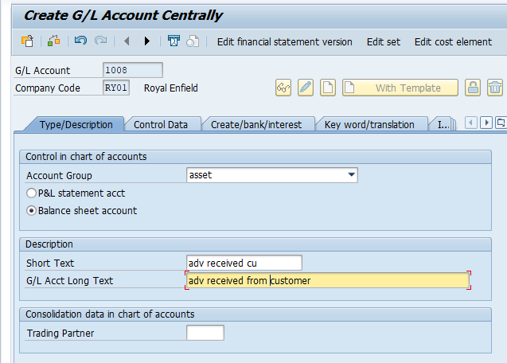
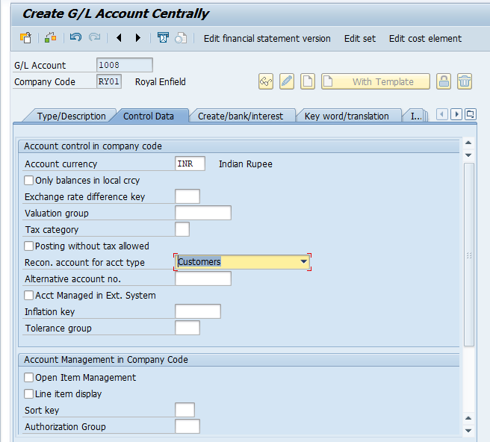
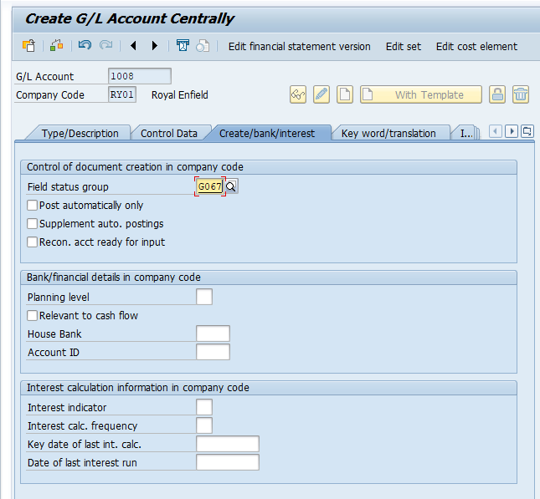
Link adv recived gl ac with normal ledger ac T – code : OBXR
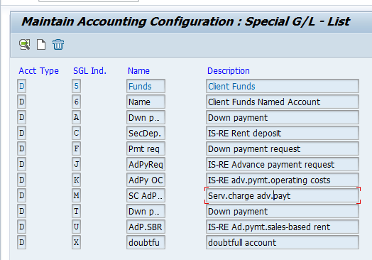
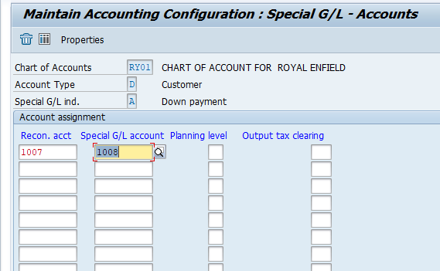
Customer advance accounting
Advance received from customer. T – code : F -29 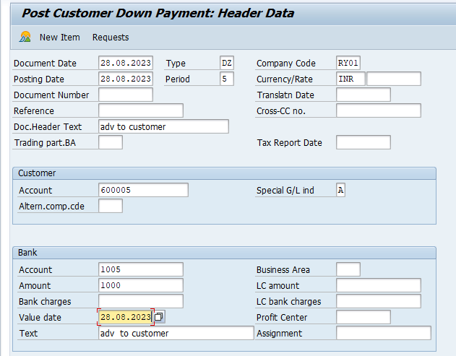
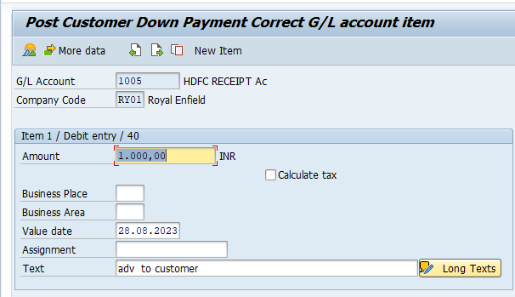
Post sales inv again customer adc payment : T – code : FB70 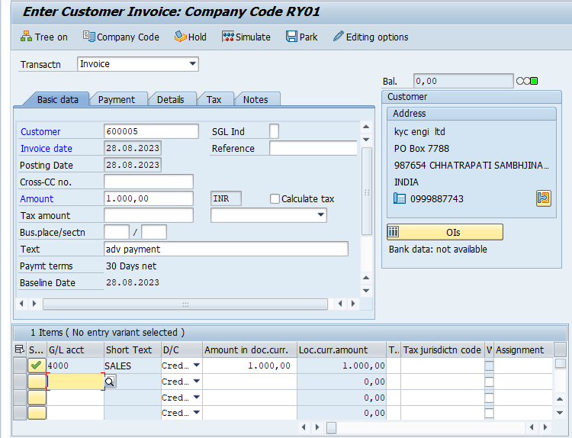
Transfer adc balance to normal ledger : F -39 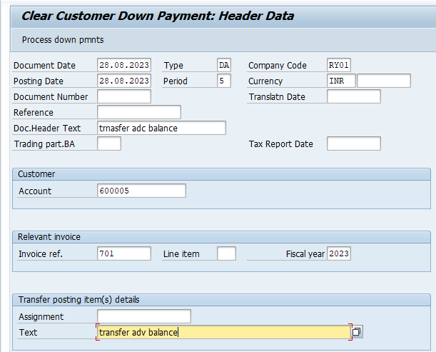
e 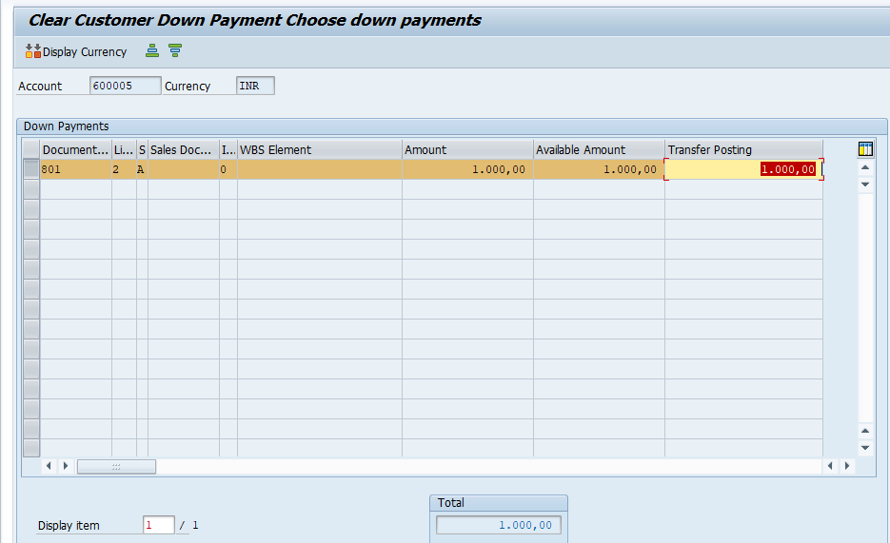
clear advance : F -32
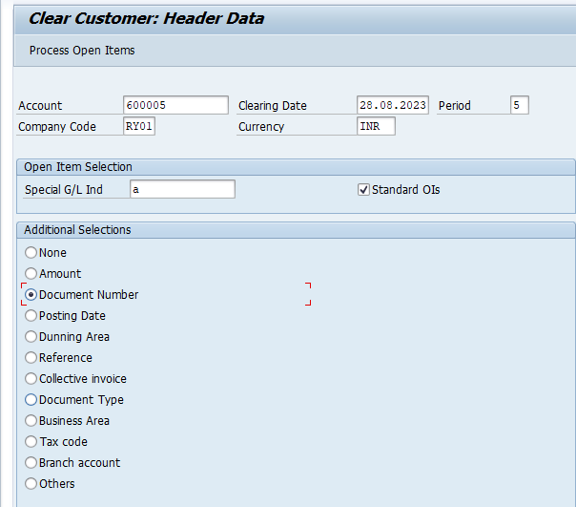
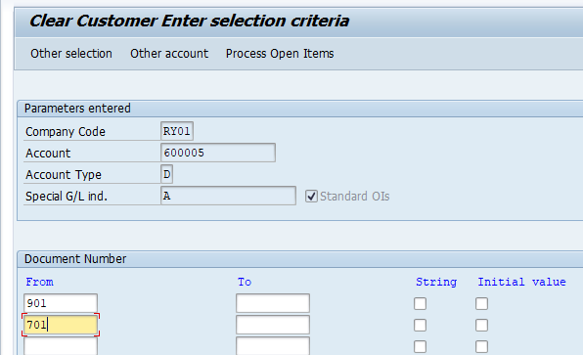
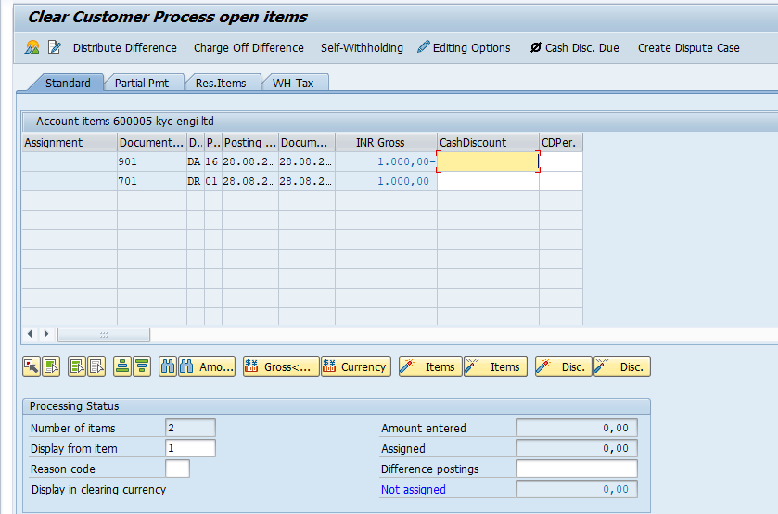

What is dunning process :
Dunning is send reminder to customer for the outstanding balance
Configuration setting :
T – code : FBMP = For dunning process
- New procedure
- Dunning levels
- Charges
- Minimum amount
- Dunning texts

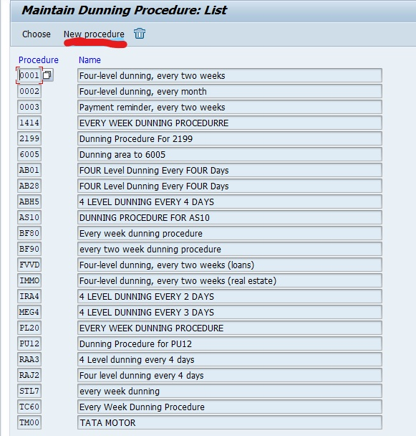
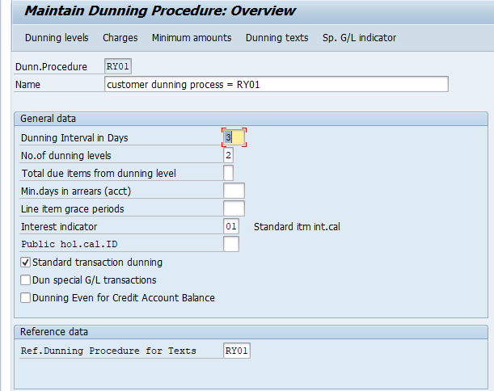
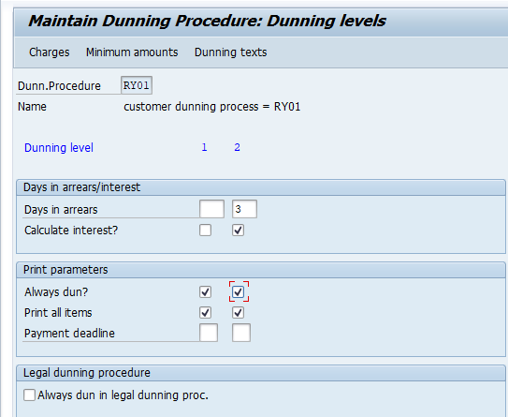
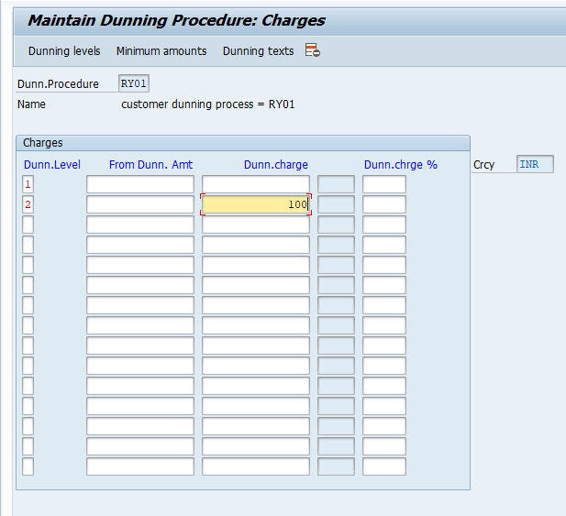

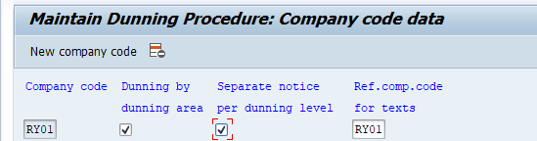
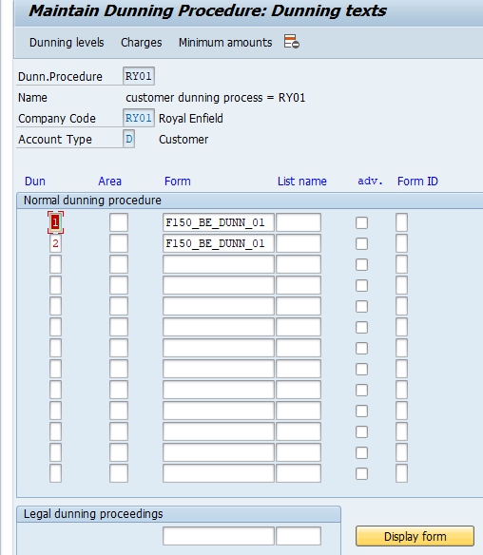
Assign dunning producer to customer account T – code = FD02
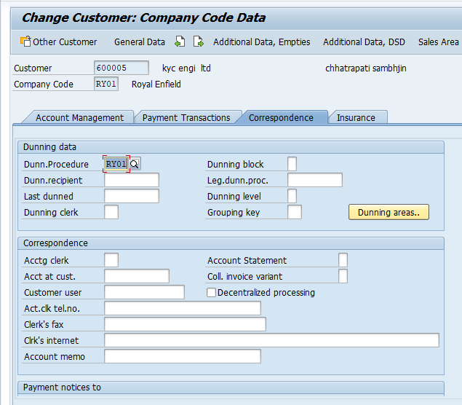

Run dunning process T – code = F150

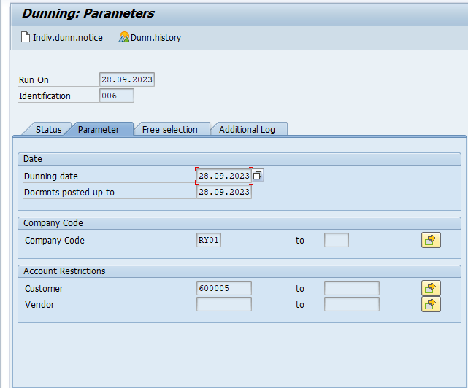
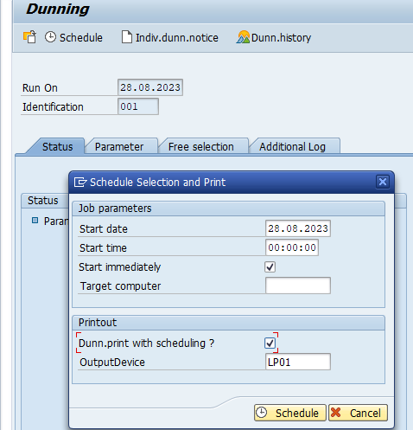
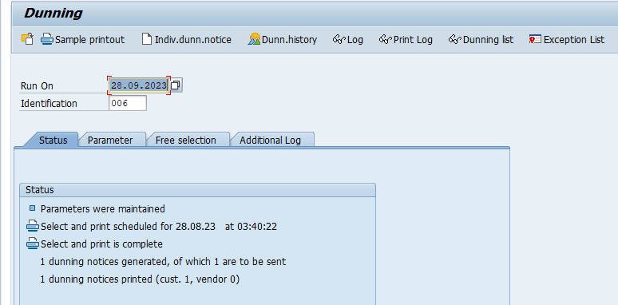
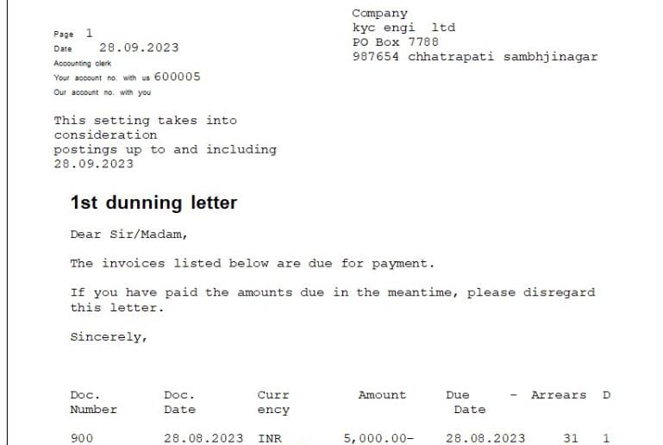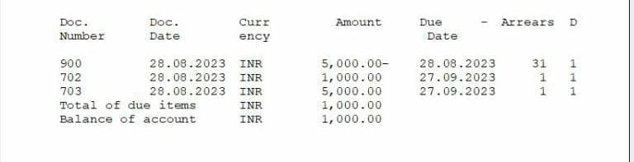
Tax on sales and purchases
What is tax and sales on purchases
Tax to deduct o purchases and sales transaction we have to type of tax code as per follow
- Input tax – call on all purchases transaction
- Output tax – call on all sales transation
Gst tax process = goods and service tax
There are three type of Salab of gst
- CGST
- SGST
- IGST

When the CGST & SGST is apply :
If transaction is happened within state the cgst & sgst is apply
Ex. Transaction is happened maharashta to maharashtra.

When th IGST is apply :
If transaction is happened outstate then the igst is apply
Ex. Maharashtra to goa
Per% | CGST | SGST | IGST
5 | 2.5% | 2.5% | 5%
12 | 6% | 6% | 12%
18 | 9% | 9% | 18%
28 | 14% | 14% | 28%

Sap configuration
Define procedure
Path : spro/sap ref img/financial accounting (new)/financial accounting global setting (new) / tax on sales on purchases/ basic setting/ check calculation/ procedure
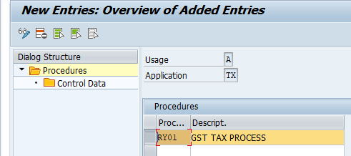

2.Define condition types :
Path : spro/sap ref img/financial accounting (new)/financial accounting global setting (new) / tax on sales on purchases/ basic setting/ check calculation/ define condition types.

Input out-put
JICG | IN-CGST |  | JOCG | OT-CGST
JISG | IN-SGST |  | JOSG | OT-SGST
JIIG | IN-IGST |  | JOIG | OT- IGST

Basic = Base amount
3. Assign country to calculation procedure.
Path = spro/spa ref img/ financial accounting (new)/ financial accounting/ global setting/ assign country to calculation procedure. T – code = OBBG
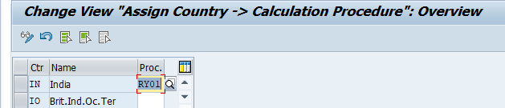
- Check and change setting for tax processing

Define account key
In-put out-put
JIC | IN-CGST |  | JOC | OT-CGST
JIS | IN-SGST |  | JOSG | OT-SGST
JII | IN-IGST |  | JOIG | OT-IGST

5. Assign condition type and and account tax process
Path : spro/ sap ref img/ finacial accounting (new)/ financial accounting globle setting (new)
Tax-service-purchases/basic setting/check calculation process
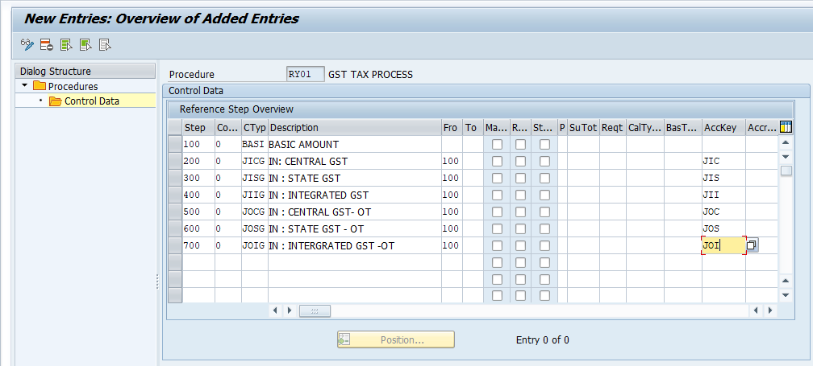

- Create gl master (6) = FS00
ASSET GROUP | LIABILITY GROUP

IN – CGST | OT – CGST
IN – SGST | OT – SGST
IN - IGST | OT - IGST

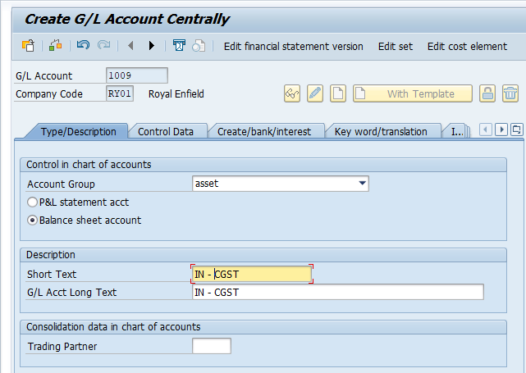
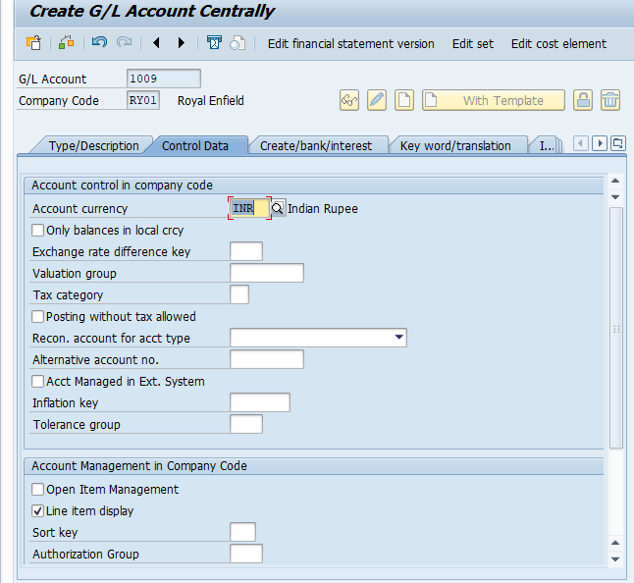
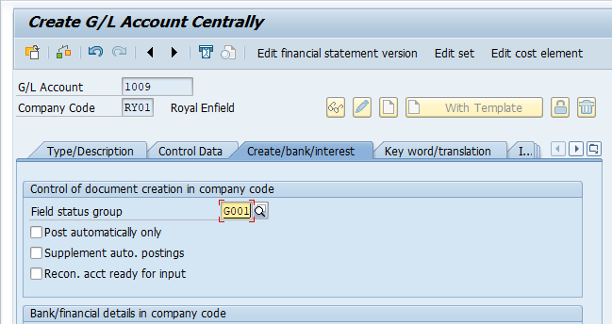

Same create in- sgst & in – igst

Crete liability group
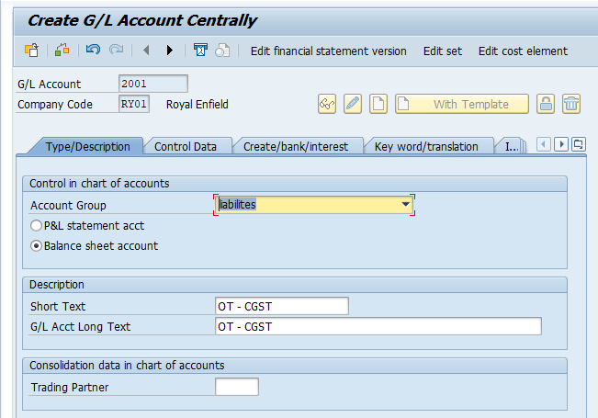

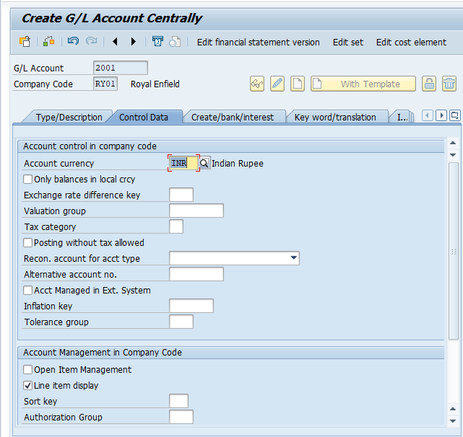

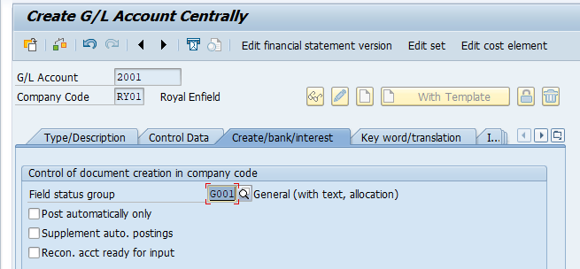
Same create in- sgst & in – igst

- Define tax amount
Path : spro/sap ref img/finacial accounting (new)/ financial accountin global setting (new)/ tax on sales ( purchases)/ posting/ define tax amount
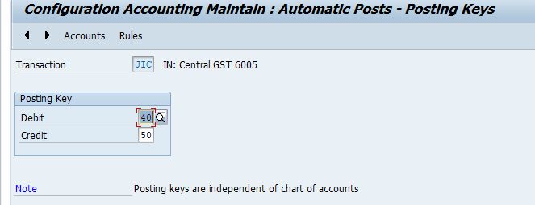

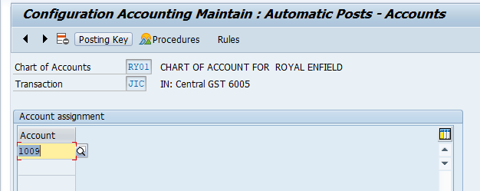

Creat same in - sgst/in – igst
ot – tax code assign
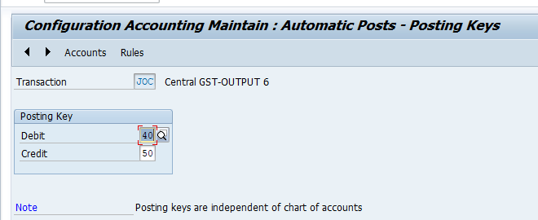

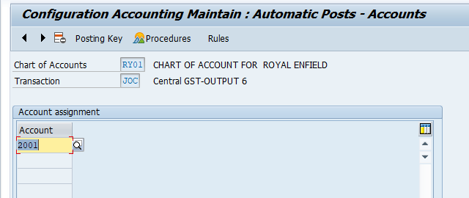
Crete same ot-sgst/ot – igst
- Define tax code T- code : FTXP
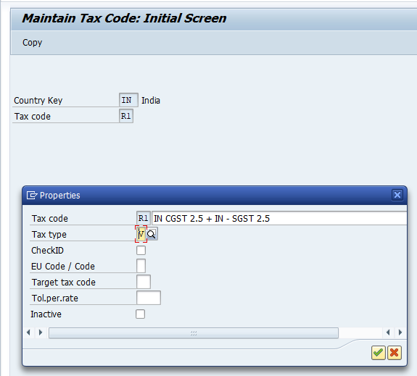

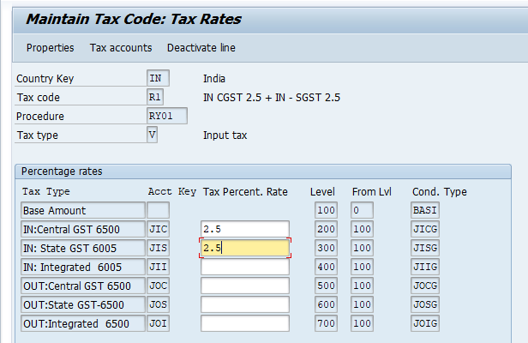

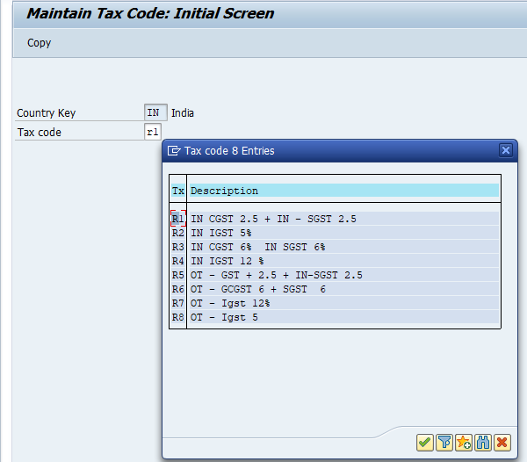
- Activate gl account for tax posting ( purchase & sales gl ) T – code = FS00
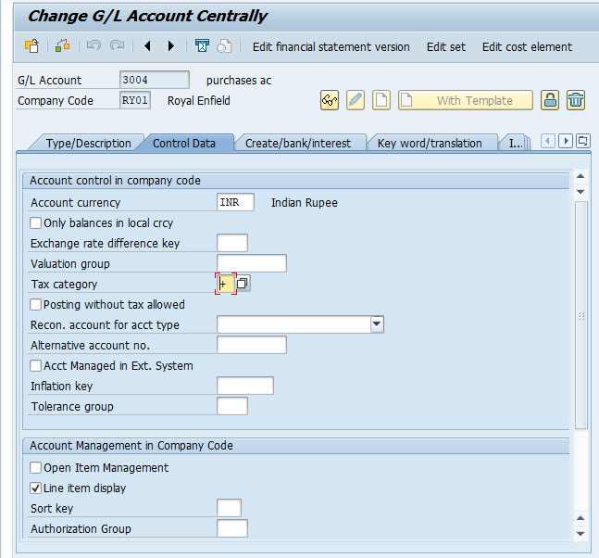

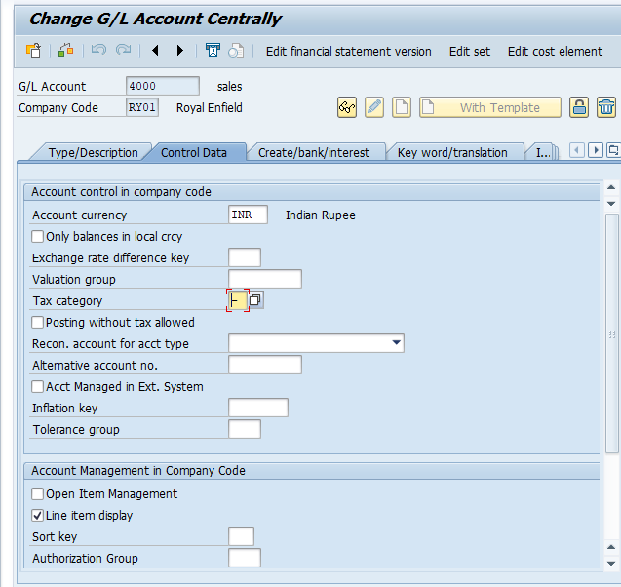

Taxable transaction posting :
Fb60 = purchases inv with tax - gst
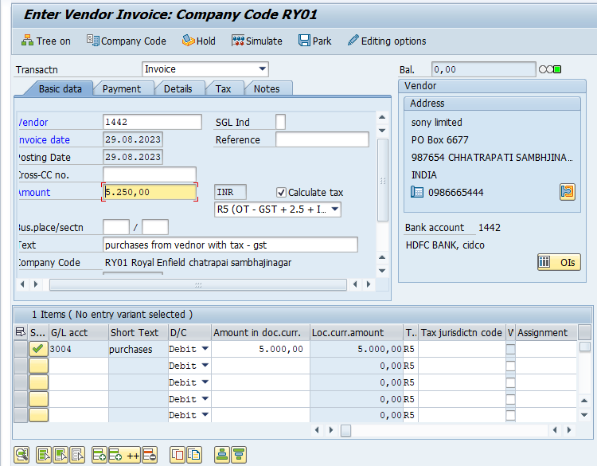

FB70 = Sales inv with tax- gst
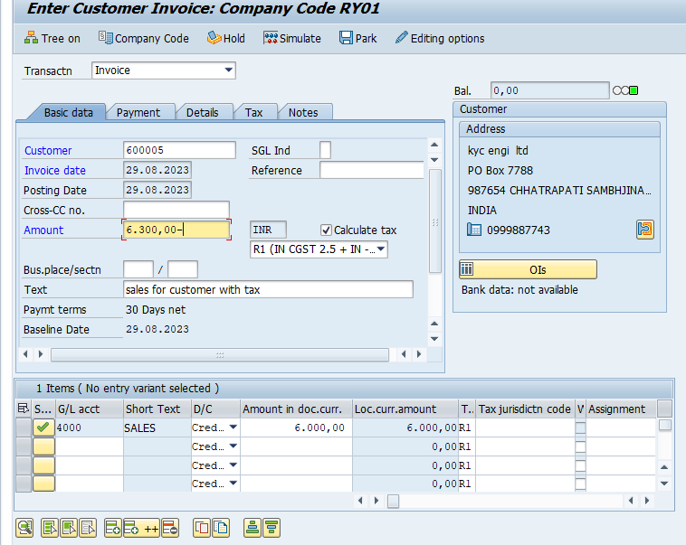

Asset accounting
The asset accounting ( FI-AA) componet is used manging nad supervising fixed assets with the sap system in financial accounting. It serves as a subsidery ledger to the general ledger. Providing detailed information on transcation involing fixed assets.
Fixed assets
Ex. Land & building , computer, furnitures, fixtures, laptop,plant,& machinery
Step of asset accounting :
- Asset accquistion/purchase
- Dep past on asset

5 life

Asset accquistion/ purchase
Asset depreciation calculation

Plant & machinery life in 5 year 100000 10%

Deprecation calculation method :
- Fixed asset method ( SLM )
- Written down value method (wdv)

Slm : in slm method dep charged fixed for every year

Asset life value dep % net book value
P&m 5 100000 10%

First year apc 100000 10000 90000
Second yeat apc 100000 10000 80000
Third yeat apc 100000 10000 70000

2 . WDV : in method dep not charged fixed every it may differed for every year

Asset life value dep% net book value
P&m 5 100000 10

First year apc 100000 10000 90000
Second yeat apc 10000 9000 81000
Third yeat apc 10000 8100

Note :
SLM : slm method dep calcualtion on acquisition value
WDV : wdv method dep calcualtion on net book value

Asset configuration part :

Intergrate with general ledger accounting :

1. assign input tax indicator for non-taxable acquisitions:
Path : spro/sap ref img/ financial accounting (new)/asset accounting/ intergrate with general ledger accounting/assign input tax indicator for non-taxable
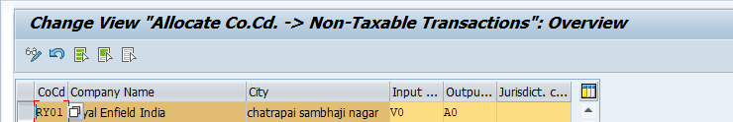

Organization structure :
- copy referance chart of deprecation/ depreciation area :
- Specify description of chart of deprecation
- Copy/delete deprecation areas
Same Path : spro/ sap ref img/financial accounting/asset accounting/originizational structures/ copy reference chart of deprecation/deprecation area 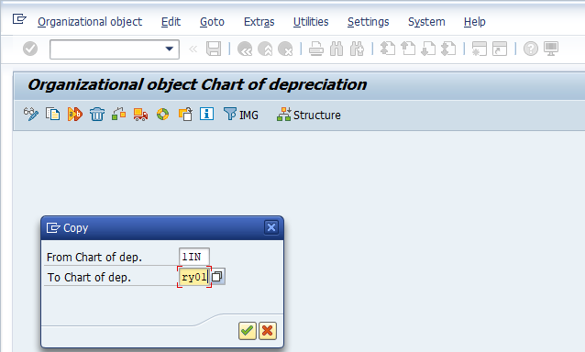
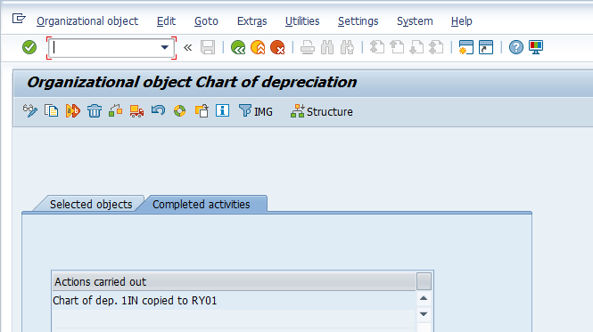

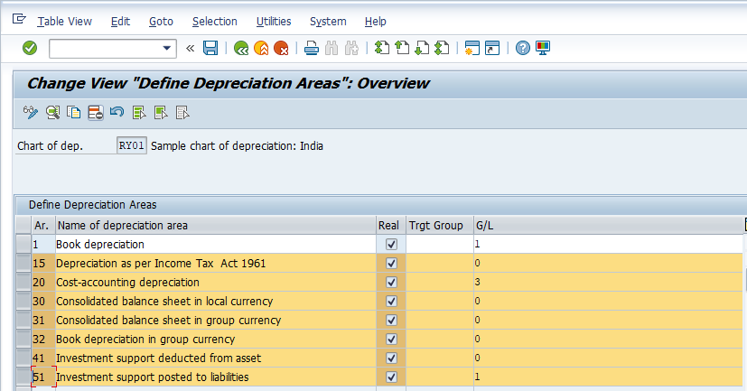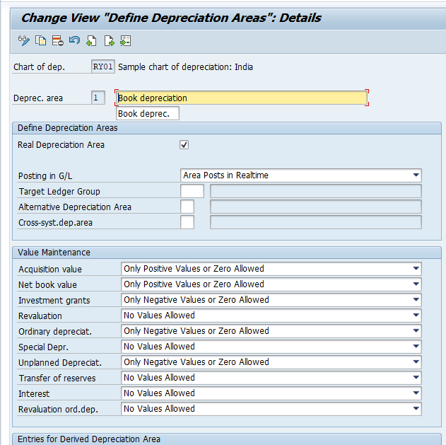
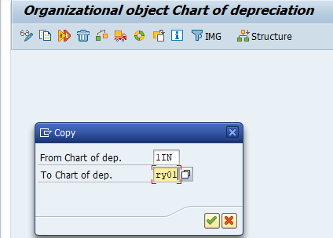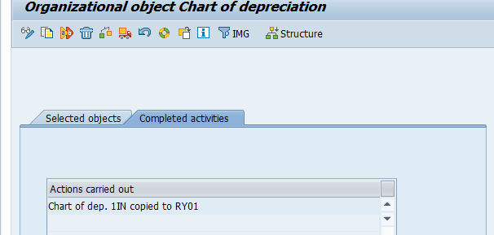
- assign chart of deprecation to company code.
Path : spro/sap ref img/finacial accounting(new)/asset accouting/organization structure/assign chart of deprecation to company code 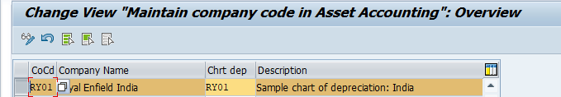
Asset classes :
- Sepecify accounting determination
Path: spro/sap ref img/financial accounting (new)/asser accounting/organization strucutures/asset accounting/specify account determination. 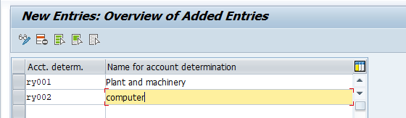
- Create screen layout rules.
Path: spro/sap ref img/financial accounting (new)/asser accounting/organization strucutures/asset accounting/create screen layout rules. 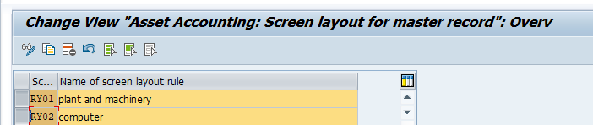
- Define number range interval : T-code : AS08
Path: spro/sap ref img/financial accounting (new)/asser accounting/organization strucutures/asset accounting/define number range interval 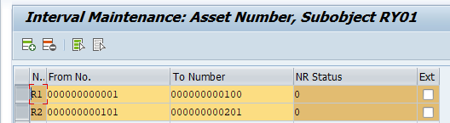
- Define asset classes.
Path: spro/sap ref img/financial accounting (new)/asser accounting/organization strucutures/asset accounting/define asset classes
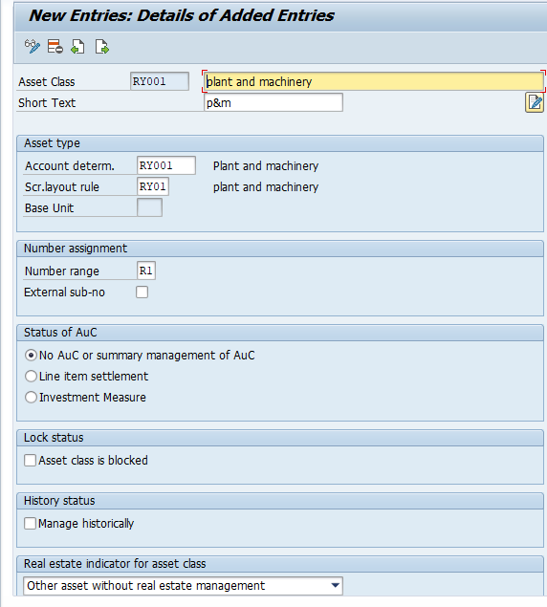
Same create computer

Master data part :
- Gl /master : (FS00)
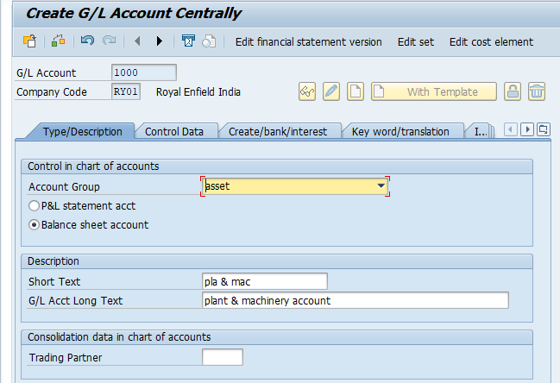
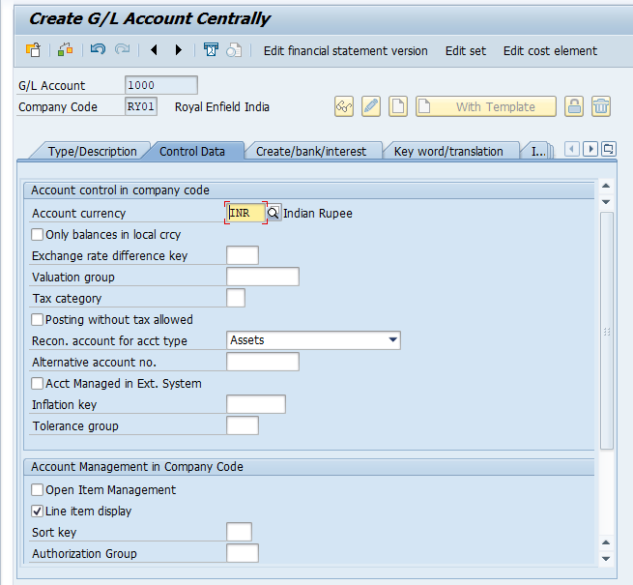
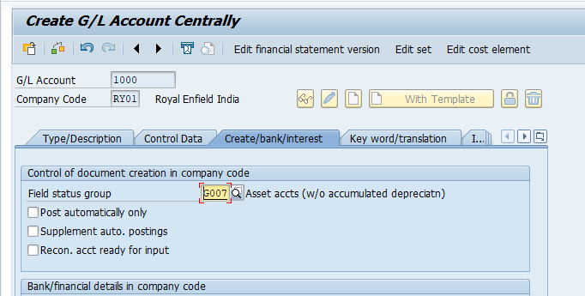

Accumlated dep acc
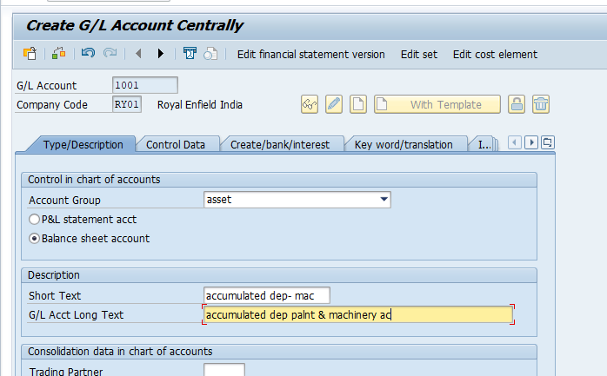

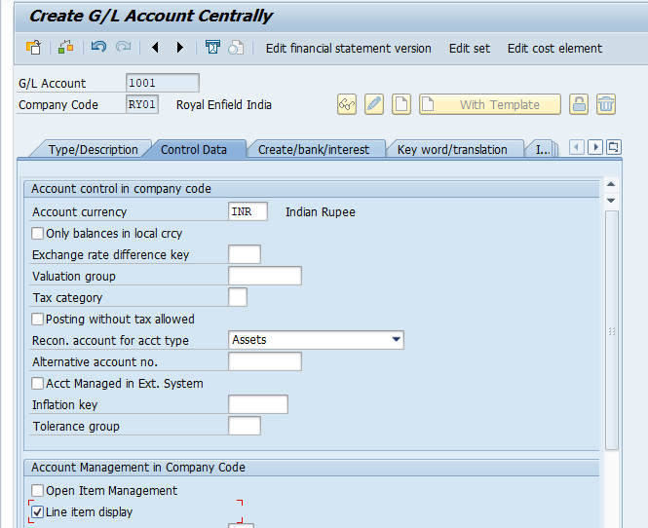

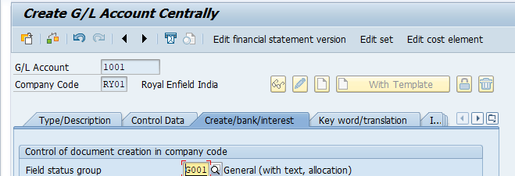

Dep on machinery
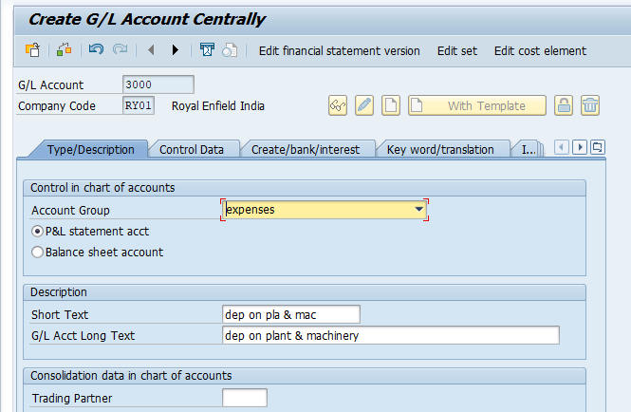

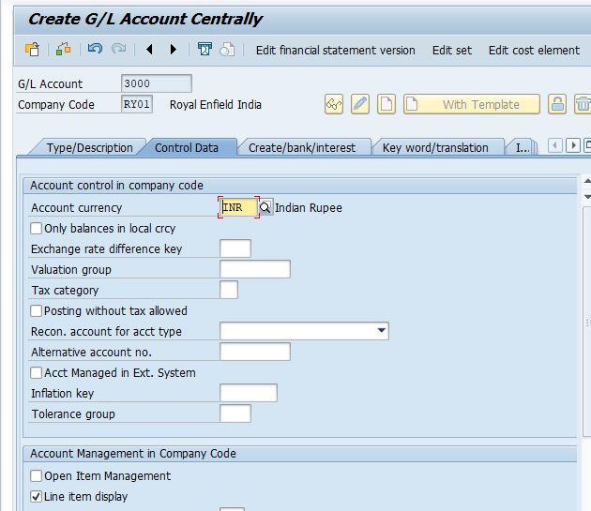

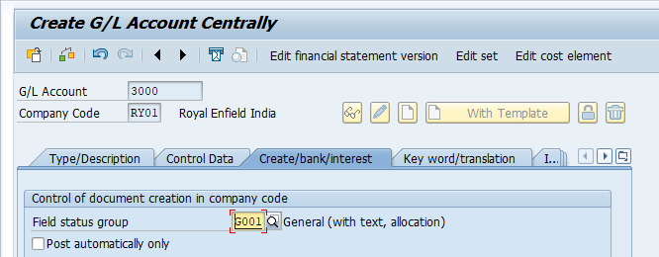

Integration gl account
Assign gl account : path : spro/sap ref img/finacial accounting new/asset accountign/ intefration with general ledger/ assign gl account /chart of depreacation area

Valuation :
- Determine deprecation areas in the asset class.
Path = spro/sap ref img /financial accounting ( new)/ asset accounting/ valuation/ determine deprecation area is asset class
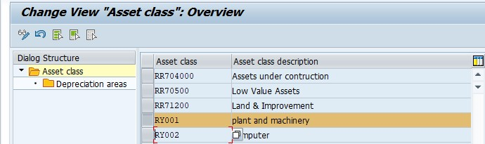

Depreciation : define deprecation calcuation/ valuation method
- Base method
- Define multilevel method
- Maintain period control method.

1 Base method :
Path : spro/spa ref img/financial accounting (new)/asset accounting/deprecation/valuation method/deprecation key/calucaltion method/ define base method
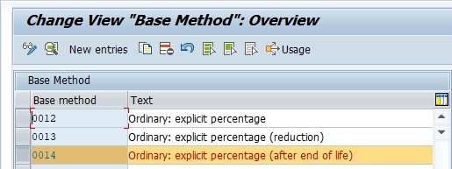

- define multilevel method ( SLM & WDV METHOD)
Path : spro/spa ref img/financial accounting (new)/asset accounting/deprecation/valuation method/deprecation key/calucaltion method/ define multilevel method

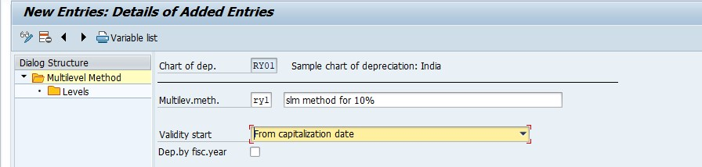
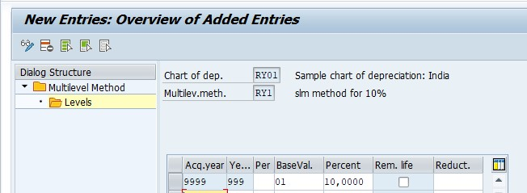

WDV method
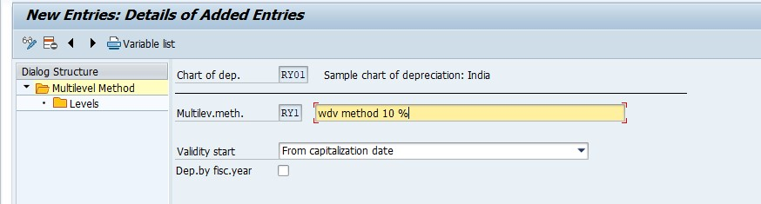
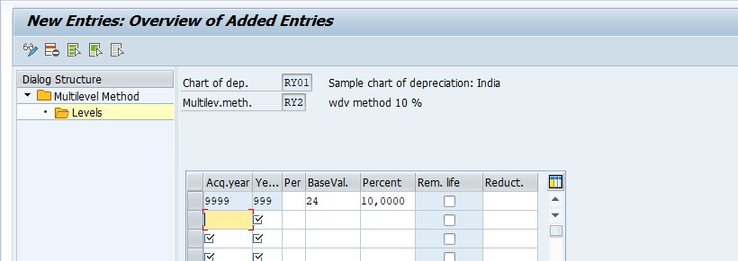
- Maintain period control method
Defination : the maintain period control use in sap calualated/control on deprecation in sap

- Maintain deprecation key
Path : spro/spa ref img/financial accounting (new)/asset accounting/deprecation/valuation method/deprecation key/calucaltion method/ maintain deprecation key
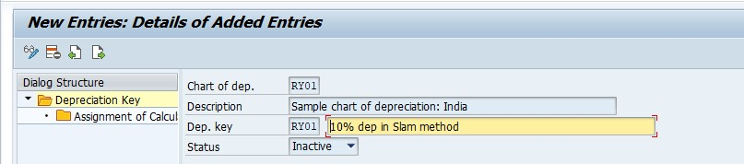

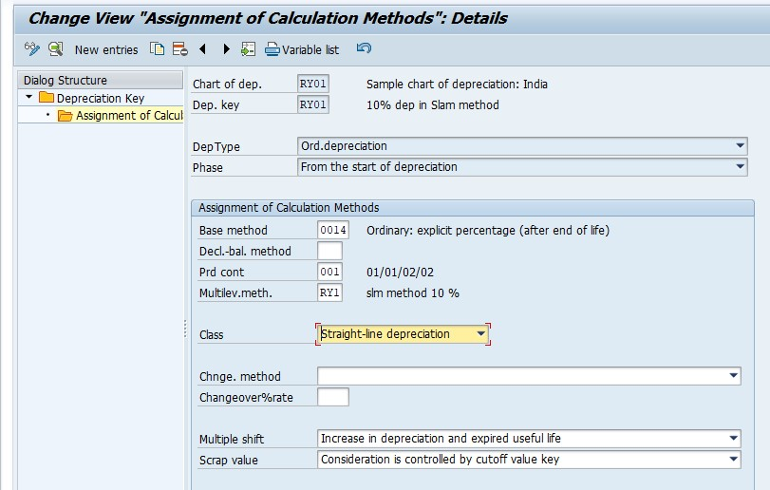

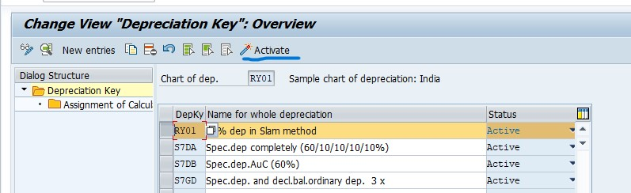
WDV METHOD
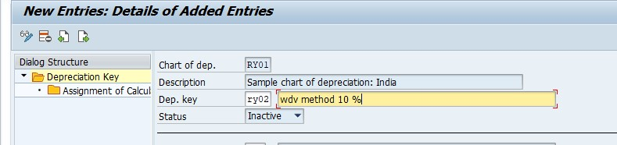
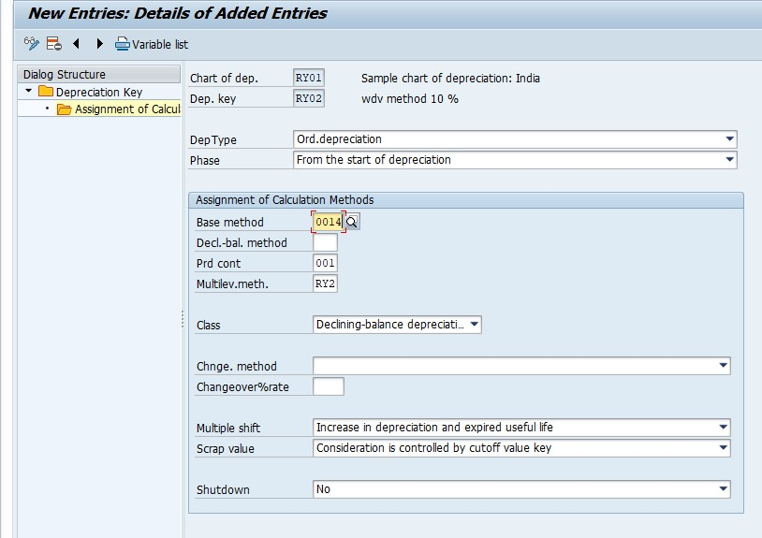
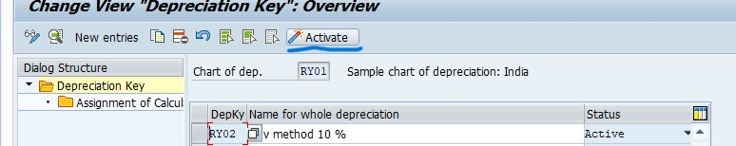
Asset master creation
1 . asset master creation : T – code : AS01
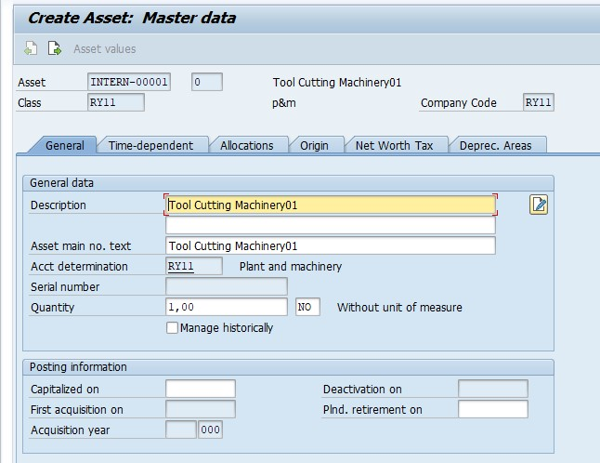
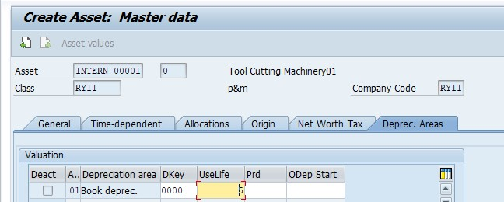
- ASSET MASTER CHANGE : T – CODE : AS02
- ASSET MASTER DISPLAY : T- CODE : AS03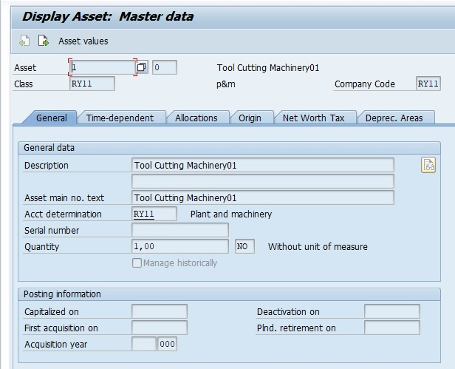
- SUB ASSET CREATION : AS11
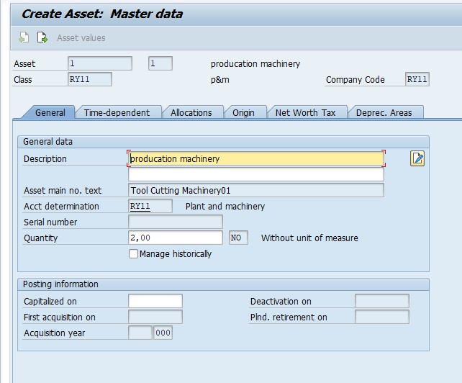

- the asset is main sr.no : 0
- the sub- asset is sr.no :1

TDS
- System configuration
- Configuration witholding tax
- Check witholding tax countries
Path : spro/sap ref img/financial accounting (new)/financial accounting global setting new/witholding accounting/ extended witholding tax/basic setting/ check setting tax countries
- Define witholding tax keys
Path : spro/sap ref img/ financial accounting new/ finacial accounting global setting (new)/ withodling tax/extended witholding tax/ basic setting/ define witholding tax types
- Witholding tax type
- Define witholding tax type for invoice posting
Path : spro/sap ref img/financial accounting (new) / finanical accounting global setting (new)/witholding tax/ extended with holding tax/ calculation/define witholding tax type/ define without tax type for invoice posting
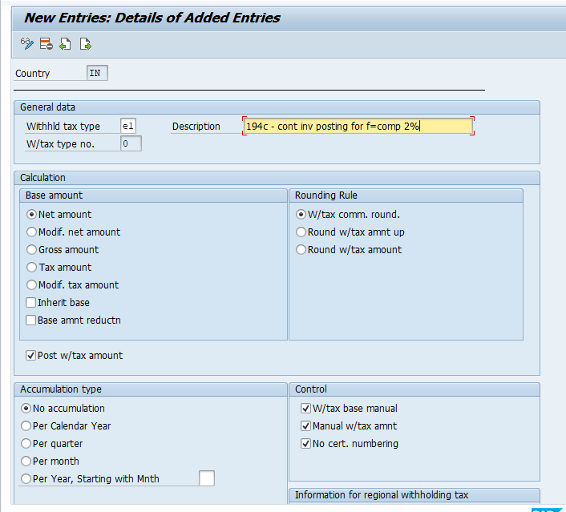
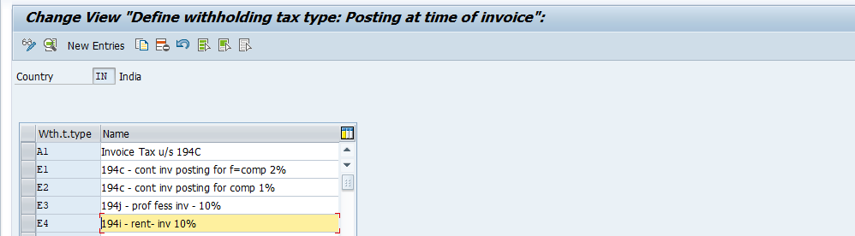
- Define witholding tax type for payment posting
Path : spro/sap ref img/financial accounting (new) / finanical accounting global setting (new)/witholding tax/ extended with holding tax/ calculation/define witholding tax type/ define without tax type for payment posting 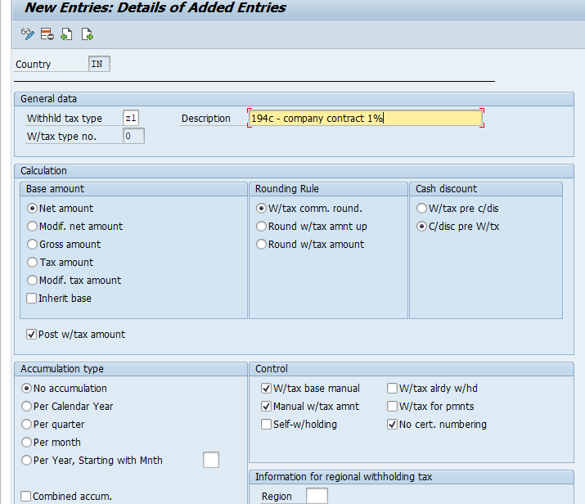

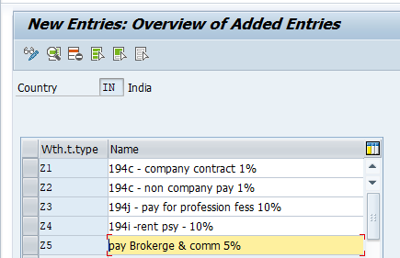

- Define witholding tax codes
Path : spro/sap ref img/financial accounting (new) / finanical accounting global setting (new)/witholding tax/ extended with holding tax/ calculation/define witholding tax code/ define witholding tax code

Invoice
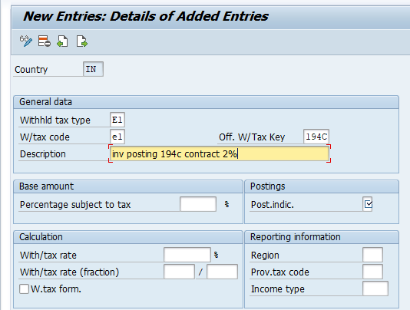

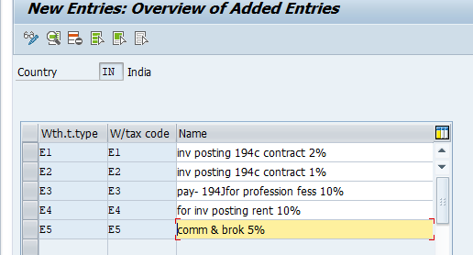

Payment
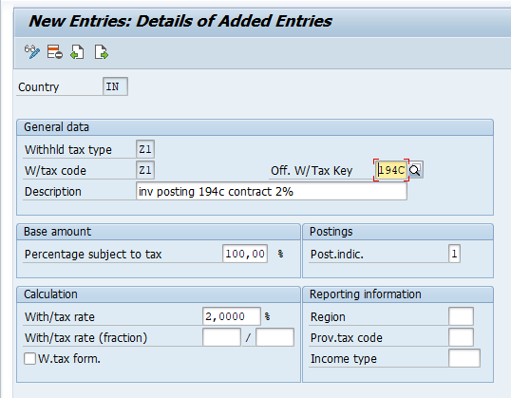

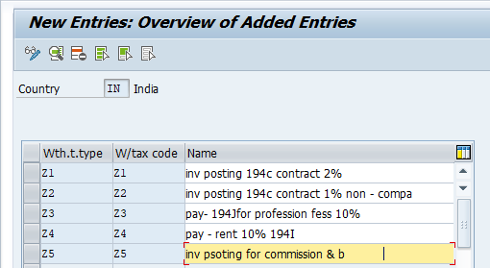

- Check recipient payment
Path : spro/sap ref img/financial accounting (new) / finanical accounting global setting (new)/witholding tax/ extended with holding tax/ basic setting/ check recipiet types
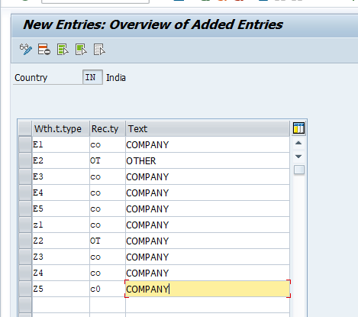

- Assign witholding tax types to company code
company code/ Assign witholding tax types to company code 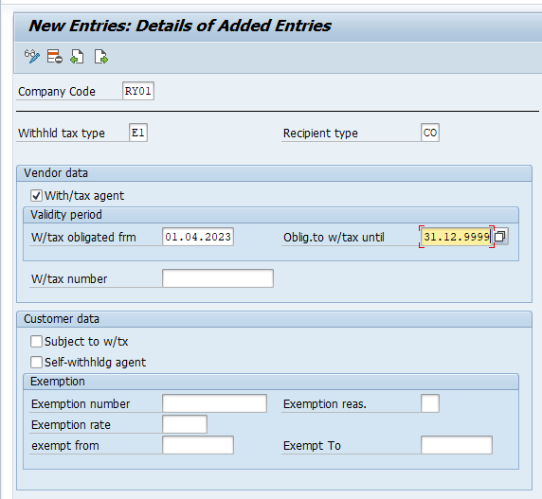
Similarly all assign tax code
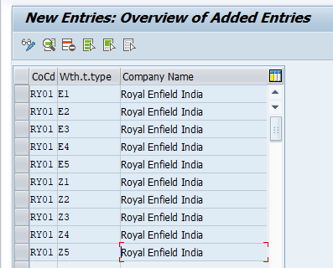

- Activate extended witholding tax
Path : spro/sap ref img/financial accounting (new) / finanical accounting global setting (new)/witholding tax/ extended with holding tax/company code/ extended witholding tax
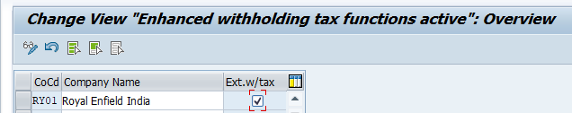

- Create gl acccount : ( tds payable )
T – code = FSOO 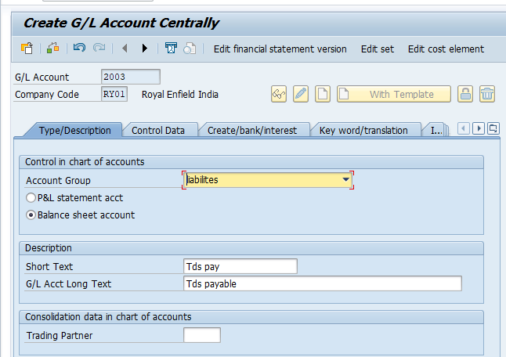

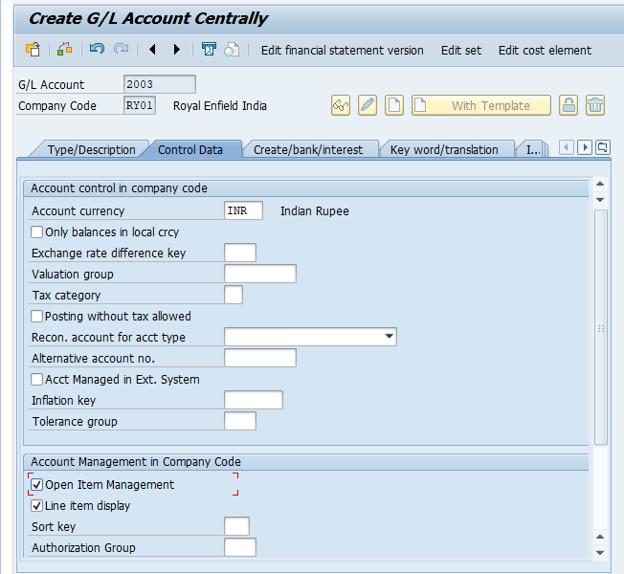
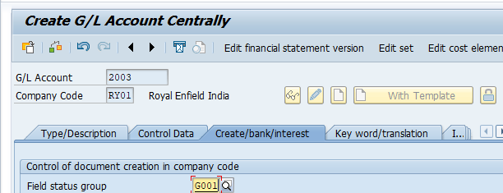

8 . define accounts for witholding tax to be paid over
Path : spro/sap ref img/financial accounting (new) / finanical accounting global setting (new)/witholding tax/ extended with holding tax/posting/ account for withholding tax/ define account for withholding tax to be over.
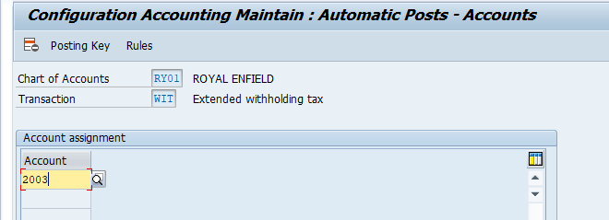

Master data updating
Assign withholding tax type and tax code to vendor master : FK02
